**Welcome to New Bethel Baptist Church**

**Prelude** Dr. Christina Romero-Ivanova

**\*Call to Worship**

***All: Christ Arose***

**Opening Music** *Worship Medley*

**Welcome and Greeting**

\***Gathering Hymn**  *Worship Christ the Risen King!* #361

**\*Invocation and Lord’s Prayer (***using “sins”*) Karen Pappas

**Scripture Reading** John 20:1-18 Karen Pappas

**Worship Prayer**

**\*Hymn** *Rejoice the Lord is King* #370

**Children’s Sermon**

**Scripture Reflection** Mark 16:1-8 Rev. Tom Bartley

**\*Hymn**  *He Lives* #368

**Ministry Opportunities** Karen Pappas

Meditation on Tithes and Offerings

*Doxology #815

*Prayer Karen Pappas

**Communion Hymn** *Come, Share the Lord* #462

**Communion**

**\*Closing Hymn** *Blest Be the Tie That Binds* #425

**Postlude**  Dr. Christina Romero-Ivanova

**Happening This Week**

Today 10:30 a.m. Live-stream and In-person worship

Thursday 10-11:30 a.m., Book discussion Group, contact

Janie Bryant

Thursday 7 p.m. Pastor’s Bible Study Group on Zoom

*\*\*\*\*\*\*\*\*\*\*\*\*\*\*\*\*\*\*\*\**

**Daily Prayer Calendar**

* **Monday, April 5, 2021**: Psalm 118:1-2, 14-24; Genesis 1:1-

19; 1 Corinthians 15:35-49

* **Tuesday, April 6, 2021**: Psalm 118:1-2, 14-24; Genesis 1:20-

2:4a; 1 Corinthians 15:50-58

* **Wednesday, April 7, 2021**: Psalm 118:1-2, 14-24; Song of

Solomon 3:1-11; Mark 16:1-8

* **Thursday, April 8, 2021**: Psalm 133; Daniel 1:1-21; Acts

2:42-47

* **Friday, April 9, 2021**: Psalm 133; Daniel 2:1-23; Acts 4:23-

31

* **Saturday, April 10, 2021**: Psalm 133; Daniel 2:24-49; John

12:44-50

* **Sunday, April 11, 2021:** Acts 4:32-35; Psalm 133; 1 John 1:1-2:2; John 20:19-31

**WELCOME TO NEW BETHEL BAPTIST CHURCH**

**We are blessed by your presence!**

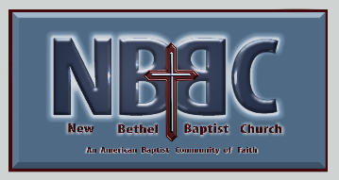

**GUEST AND MEMBERS:** If you have questions or would like more information about New Bethel, please feel free to contact the church office. Thank you!

*An American Baptist*

*Congregation*

**\*\*\*\*\*\***

**ALL ARE WELCOME**

**Weekly Activities Online Only**

**Thursdays** online Zoom Book Discussion, *If God Is Love,* 10 a.m.,

Contact Janie Bryant

**Thursdays** online Pastor’s Bible Study Group, 7 p.m. on Zoom,

Contact Janie Bryant, or Pastor Tom if you would like to join.

**Sunday Worship**, 10:30 a.m., Live-stream Only

**\*\*\*\*\*\***

**CONTACT INFORMATION**

New Bethel Baptist Church **Website:** www.newbethelbapt.org

8936 Southeastern Avenue **E-mail:** newbethelbapt@att.net

Indianapolis, IN 46239 **Wi-fi password:** NBBC8624381

317-862-4381 **Instagram:** NBBC.Wanamaker

**YouTube:** New Bethel Baptist Church Wanamaker

https://facebook.com New Bethel Baptist.Wanamaker

Rev. Tom Bartley, Interim Pastor

Lori Chapman, Church Secretary

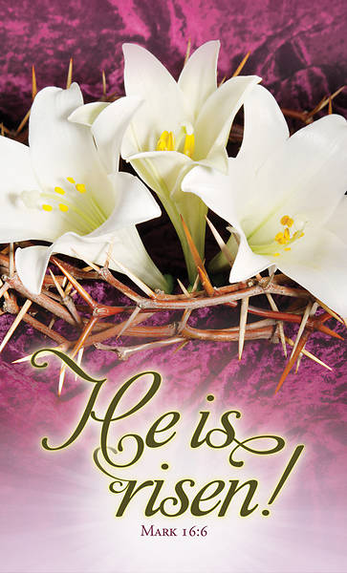

**Engaging Young Adults Grant Ended**

The Engaging Young Adults Team decided to end the grant process. We made this decision for several reasons:

* Difficulty of completing projects due to COVID 19 restrictions.
* Current conflict within the New Bethel Baptist Church congregation.
* Financial considerations.

We will not need to repay The Center for Congregations any of the grant money that we have already spent.

The EYA Team put a lot of time, energy, and prayer into this project. We thank all of you for your participation through attending information sessions, completing surveys, brainstorming ideas for ways to engage young adults and praying.

EYA/Strategic Planning Team

*\*\*\*\*\*\*\*\*\*\*\*\*\*\*\*\*\*\*\*\**

**Worship Music Copyright and Live-Streaming Permissions**

**All above selections ©1997 Word/Integrity Used by Permission.**

**CCLI License #1631733**

See hymns within the bulletin listed.

*\*\*\*\*\*\*\*\*\*\*\*\*\*\*\*\*\*\*\*\**

“Mountain Suite Overture” by Bill George & Dino Kartsonakis

“In the Sweet By and By” by Bill George & Dino Kartsonakis

“Love Cn Build a Bridge” by Naomi Judd, John Barlow Jarvis, Paul

Overstreet, Bill George, Dino Kartsonakis

“He Looked Beyond My Faults and Saw My Needs” by Bill George

& Dino Kartsonakis

“You are My Hiding Place” by Michael Ledner

“Great Are You, Lord” by Steve and Vikki Cook

“Spirit Song” by John Wimber