**Welcome to New Bethel Baptist Church**

*Seventh Sunday of Easter,* **May 16, 2021**

**Prelude** Dr. Christina Romero-Ivanova

\***Gathering Music** *I Will Follow*

*10,000 Reasons*

**\*Call to Worship**

One:  Let us come together and worship the Lord.

Many:  God calls us together as one people.

One:  We are united with all believers in worship.

Many:  We are one in spirit.

One:  Come, let us worship the Lord.

All:  Let us praise the God who has redeemed us.

**\*Hymn** My Faith Looks Up to Thee #539

**\*Invocation and Lord’s Prayer (***using “sins”*) Karen Pappas

**Scripture Reading** Judges 14:1-9 Karen Pappas

**Worship Prayer**

*Cares Chorus* #627

**Children’s Sermon**

**\*Hymn**   *When Morning Gilds the Skies* #215

**Scripture Reflection** Mark 12:1-12 Rev. Tom Bartley

**\*Hymn**  *Jesus Loves Me* #185

**Ministry Opportunities** Karen Pappas

Meditation on Tithes and Offerings

*Doxology #815

*Prayer Karen Pappas

**Benediction**

**Postlude**  Dr. Christina Romero-Ivanova

**Happening This Week**

Today 10:30 a.m. Live-stream and In-Person Sunday worship

Thursday 10-11:30 a.m., Book discussion, contact Janie Bryant

Thursday 7 p.m. Pastor’s Bible Study on In-Person and Zoom

*\*\*\*\*\*\*\*\*\*\*\*\*\*\*\*\*\*\*\*\**

**Daily Prayer Calendar**

* **Sunday, May 16, 2021**: Acts 1:15-17, 21-26; Psalm 1;

1 John 5:9-13; John 17:6-19

* **Monday, May 17, 2021**: Psalm 115; Exodus 28:29-38;

Philippians 1:3-11

* **Tuesday, May 18, 2021**: Psalm 115; Numbers 8:5-22;

Titus 1:1-9

* **Wednesday, May 19, 2021**: Psalm 115; Ezra 9:5-15;

John 16:16-24

* **Thursday, May 20, 2021**: Psalm 33:12-22; Genesis 2:4b-7;

1 Corinthians 15:42b-49

* **Friday, May 21, 2021**: Psalm 33:12-22; Job 37:1-13;

1 Corinthians 15:50-57

* **Saturday, May 22, 2021**: Psalm 33:12-22; Exodus 15:6-11;

John 7:37-39

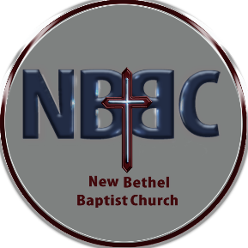**WELCOME TO NEW BETHEL BAPTIST CHURCH**

**We are blessed by your presence!**

**GUEST AND MEMBERS:** If you have questions or would like more information about New Bethel, please feel free to contact the church office. Thank you!

*An American Baptist Congregation*

**\*\*\*\*\*\***

**ALL ARE WELCOME**

**Weekly Activities Online Only**

**Thursdays** online Zoom Book Discussion, *If God Is Love,* 10 a.m.,

Contact Janie Bryant

**Thursdays** online Pastor’s Bible Study Group, 7 p.m. on Zoom and

In-Person. Contact Janie Bryant, or Pastor Tom if you would

like to join.

**Sunday Worship**, 10:30 a.m., Live-stream and In-Person

**\*\*\*\*\*\***

**NBBC CHURCH CLOTHING PANTRY RE-OPEN**

NBBC Clothing Pantry is open each Thursday. Men’s, women’s, and children’s sizes are available. **All clothing is free.** If you would like to serve others in this way, you may contact Sue Winton (317-358-7762). We welcome men or women volunteers. Currently, we are having one person working on open days, but if you don’t want to work alone feel free to invite a friend to work with you. Masks and social distancing are required.

**\*\*\*\*\*\***

**CONTACT INFORMATION**

New Bethel Baptist Church **Website:** www.newbethelbapt.org

8936 Southeastern Avenue **E-mail:** newbethelbapt@att.net

Indianapolis, IN 46239 **Wi-fi password:** NBBC8624381

317-862-4381 **Instagram:** NBBC.Wanamaker

**YouTube:** New Bethel Baptist Church Wanamaker

New Bethel Baptist.Wanamaker

Rev. Tom Bartley, Interim Pastor

Lori Chapman, Church Secretary

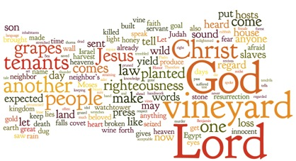

**Worship Music Copyright and Live-Streaming Permissions**

**All selections ©1997 Word/Integrity Used by Permission.**

**CCLI License #1631733**

See hymns within the bulletin listed.

“I Will Follow” by Kelly Moore

*\*\*\*\*\*\*\*\*\*\*\*\*\*\*\*\*\*\*\*\**

“Wanderlust” by Jim Brickman

“Heartland by Jim Brickman

“Border” by Jim Brickman

“Rocket to the Moon” by Jim Brickman

“On Eagles Wings” by Jan Michael Joncas

“O Worship the King” by Robert Grant, William Gardener, Johann

M. Haydn, Don Marsh

“Majesty” by Jack W. Hayford, Eugene Thomas

**Live-Streaming: CCS, WorshipCast, License #10868**