**Welcome to New Bethel Baptist Church**

*Pentecost Sunday,* **May 23, 2021**

**Prelude** Dr. Christina Romero-Ivanova

\***Gathering Music** *Beautiful One*

*Jesus Loves Me*

**\*Call to Worship**

One:  Come together, people of the Lord, come and worship.

**Many:  The Spirit of the Lord is with us.**

One:  Come, Holy Spirit, come and fill this place with God’s glory.

**Many:  Come, Holy Spirit, and sanctify our gathering.**

One:  The Holy Spirit is among us.

**All:  Breathe, Holy Spirit. Fill us with your purifying fire.**

**\*Hymn** Shine, Jesus, Shine #431

**\*Invocation and Lord’s Prayer (***using “sins”*) Karen Pappas

**Scripture Reading** Genesis 11:1-9 Karen Pappas

**Worship Prayer**

*Cares Chorus* #627

**Children’s Sermon**

**\*Hymn**   *Sweet Sweet Spirit* #391

**Scripture Reflection** Acts 2:1-13 Rev. Tom Bartley

**\*Hymn**  *Breathe on Me* #396

**Ministry Opportunities** Karen Pappas

Meditation on Tithes and Offerings

*Doxology #815

*Prayer Karen Pappas

**Benediction**

**Postlude**  Dr. Christina Romero-Ivanova

**Happening This Week**

Today 10:30 a.m. Live-stream and In-Person Sunday worship

Thursday 10-11:30 a.m., Book discussion, contact Janie Bryant

Thursday 7 p.m. Pastor’s Bible Study on In-Person and Zoom

*\*\*\*\*\*\*\*\*\*\*\*\*\*\*\*\*\*\*\*\**

**Daily Prayer Calendar**

* **Sunday, May 23, 2021**: Acts 2:1-21; Psalm 104:24-34, 35b;

Romans 8:22-27; John 15:26-27; 16:4b-15

* **Monday, May 24, 2021**: Psalm 104:24-34, 35b; Joel 2:18-29;

1 Corinthians 12:4-11

* **Tuesday, May 25, 2021**: Psalm 104:24-34, 35b; Genesis

11:1-9; 1 Corinthians 12:12-27

* **Wednesday, May 26, 2021**: Psalm 104:24-34; Ezekiel 37:1-

14; John 20:19-23

* **Thursday, May 27, 2021**: Psalm 29; Isaiah 1:1-4, 16-20;

Romans 8:1-8

* **Friday, May 28, 2021**: Psalm 29; Isaiah 2:1-5;

Romans 8:9-11

* **Saturday, May 29, 2021**: Psalm 29; Isaiah 5:15-24;

John 15:18-20, 26-27

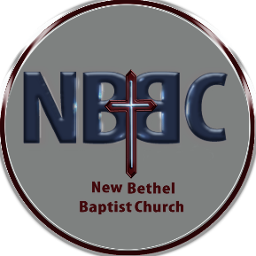**WELCOME TO NEW BETHEL BAPTIST CHURCH**

**We are blessed by your presence!**

**GUEST AND MEMBERS:** If you have questions or would like more information about New Bethel, please feel free to contact the church office. Thank you!

*An American Baptist Congregation*

**\*\*\*\*\*\***

**ALL ARE WELCOME**

**Weekly Activities Online Only**

**Thursdays** online Zoom Book Discussion, *Accidental Saints,* 10 a.m., Contact Janie Bryant

**Thursdays** online Pastor’s Bible Study Group, 7 p.m. on Zoom and

In-Person. Contact Janie Bryant, or Pastor Tom if you would

like to join.

**Sunday Worship**, 10:30 a.m., Live-stream and In-Person

**\*\*\*\*\*\***

**NBBC CHURCH CLOTHING PANTRY RE-OPEN**

NBBC Clothing Pantry is open each Thursday. Men’s, women’s, and children’s sizes are available. **All clothing is free.** If you would like to serve others in this way, you may contact Sue Winton (317-358-7762). We welcome men or women volunteers. Currently, we are having one person working on open days, but if you don’t want to work alone feel free to invite a friend to work with you. Masks and social distancing are required.

**\*\*\*\*\*\***

**CONTACT INFORMATION**

New Bethel Baptist Church **Website:** www.newbethelbapt.org

8936 Southeastern Avenue **E-mail:** newbethelbapt@att.net

Indianapolis, IN 46239 **Wi-fi password:** NBBC8624381

317-862-4381 **Instagram:** NBBC.Wanamaker

**YouTube:** New Bethel Baptist Church Wanamaker

New Bethel Baptist.Wanamaker

Rev. Tom Bartley, Interim Pastor

Julianne Thomas, Interim Church Secretary

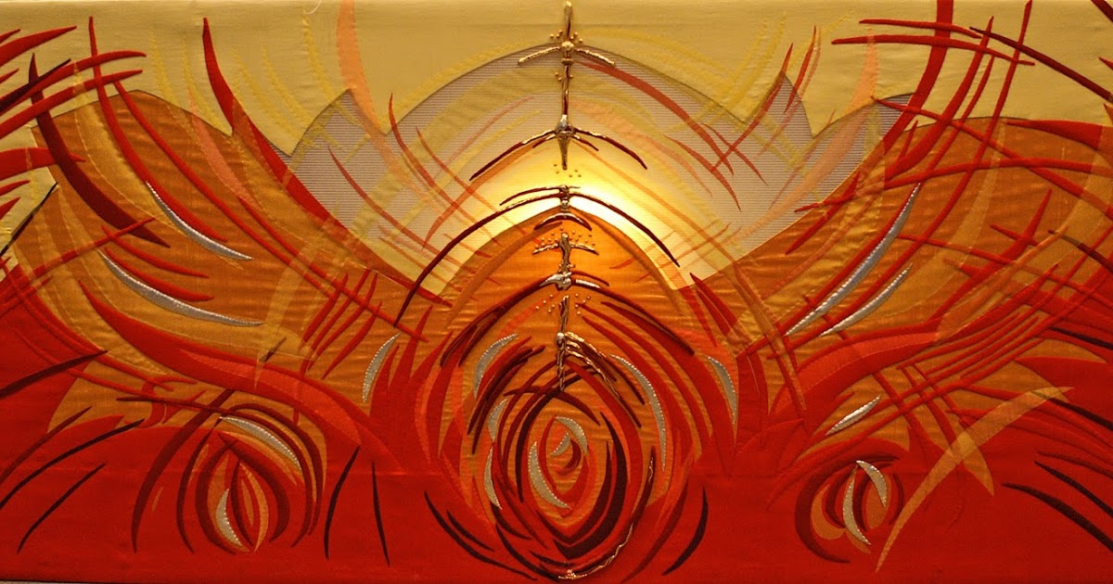

[This Photo](https://exploreandexpress-sheila.blogspot.com/2016/05/images-of-pentecost.html) by Unknown Author is licensed under [CC BY-NC-ND](https://creativecommons.org/licenses/by-nc-nd/3.0/)

Graduation Celebration

For

Zachary Huddleston

When: Saturday June 12th at 5:00 pm

Where: The firepit behind New Bethel Baptist Church

Come celebrate with us! Bring your chair or a blanket to sit on. Hotdogs, Hamburgers, Chips, and S’mores will be provided.



**Worship Music Copyright and Live-Streaming Permissions**

**All selections ©1997 Word/Integrity Used by Permission.**

**CCLI License #1631733**

See hymns within the bulletin listed.

*\*\*\*\*\*\*\*\*\*\*\*\*\*\*\*\*\*\*\*\**

“Wanderlust” by Jim Brickman

“Heartland by Jim Brickman

“Border” by Jim Brickman

“Rocket to the Moon” by Jim Brickman

“On Eagles Wings” by Jan Michael Joncas

“O Worship the King” by Robert Grant, William Gardener, Johann

M. Haydn, Don Marsh

“Majesty” by Jack W. Hayford, Eugene Thomas

**Live-Streaming: CCS, WorshipCast, License #10868**