**Welcome to New Bethel Baptist Church**

*Trinity Sunday,* **May 30, 2021**

**Prelude** Dr. Christina Romero

\***Gathering Hymns** *Hallelujah Your Love is Amazing*

*Amazing Grace My Chains Are Gone*

**\*Call to Worship**

*One:  Come together, people of the Lord.*

**Many:  The Lord will renew us.  God will restore our strength.**

*One:  Come, and sing praises to the Lord. For God is holy and merciful.*

**Many:  We come to bring the sacrifice of praise.**

*One:  God is with us. God is present in our assembly.*

**All:  Come Holy Spirit, come and sanctify God’s people. Let us become a communion of saints.**

**\*Invocation and Lord’s Prayer (***using “sins”*) Karen Pappas

**\*Hymn** *My Jesus I Love Thee #79*

**Scripture Reading** Judges 15:1-8 Karen Pappas

**Worship Prayer**

*Cares Chorus #627*

**\*Hymn**  *Jesus Loves Even Me #495*

**Children’s Sermon**

**Scripture Reflection** *Mark 12:28-34* Rev. Tom Bartley

**\*Hymn**  *They’ll Know We Are Christians by Our Love* #*429*

**Ministry Opportunities** Karen Pappas

Meditation on Tithes and Offerings

*Doxology #815

*Prayer Karen Pappas

**Postlude**  Dr. Christina Romero

**Happening This Week**

Today 10:30 a.m. Live-stream and In-Person Sunday worship

Wednesday 11:00 a.m., Zoom Book discussion, *Accidental Saints,* contact Janie Bryant

6:00 -7:00 p.m. God’s Bounty accepts donations

Thursday 1:00 -7:00 p.m. God’s Bounty serves community

2:00 -5:00 p.m. Clothing Pantry

7 p.m. Pastor’s Bible Study on In-Person and Zoom

*\*\*\*\*\*\*\*\*\*\*\*\*\*\*\*\*\*\*\*\**

**Week Ahead**

Sunday June 6th 10:30 a.m. Worship and Communion

*\*\*\*\*\*\*\*\*\*\*\*\*\*\*\*\*\*\*\**

**Thank You**

Thank you, Liz for decorating the sanctuary for Pentecost. Everything looked so nice.

The Huddlestons thank the church for the support they received and for the flowers in the loss of Dorothy Huddleston.

*\*\*\*\*\*\*\*\*\*\*\*\*\*\*\*\*\*\*\*\**

**Daily Prayer Calendar**

**Sunday, May 30, 2021:** Isaiah 6:1-8; Psalm 29; Romans 8:12-17;

John 3:1-17

**Monday, May 31, 2021**: Psalm 20; Numbers 9:15-23; Revelation 4:1-8

**Tuesday, June 1, 2021**: Psalm 20; Exodus 25:1-22; 1 Corinthians 2:1-10

**Wednesday, June 2, 2021**: Psalm 20; Numbers 6:22-27; Mark 4:1-25

**Thursday, June 3, 2021**: Psalm 130; Isaiah 28:9-13; 1 Peter 4:7-19

**Friday, June 4, 2021**: Psalm 130; Deuteronomy 1:34-40; 2 Corinthians 5:1-5

**Saturday, June 5, 2021**: Psalm 130; Genesis 2:4b-14; Luke 8:4-15

**WELCOME TO NEW BETHEL BAPTIST CHURCH**

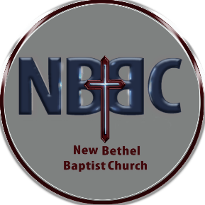 **We are blessed by your presence!**

**GUEST AND MEMBERS:** If you have questions or would like more information about New Bethel, please feel free to contact the church office. Thank you!

*An American Baptist*

*Congregation*

**\*\*\*\*\*\***

Connect With Us

New Bethel Baptist.Wanamaker

nbbc.wanamaker

New Bethel Baptist Church Wanamaker



[This Photo](http://www.pngall.com/facebook-png) by Unknown Author is licensed under [CC BY-NC](https://creativecommons.org/licenses/by-nc/3.0/)



[This Photo](https://www.android4ar.com/%D8%AA%D8%AD%D8%AF%D9%8A%D8%AB-instagram-%D8%A7%D9%86%D8%AF%D8%B1%D9%88%D9%8A%D8%AF-%D9%8A%D8%AC%D9%84%D8%A8-%D8%A7%D9%84%D9%85%D9%84%D8%B5%D9%82%D8%A7%D8%AA-%D9%88%D8%A7%D9%84%D9%81%D9%8A%D8%AF%D9%8A/) by Unknown Author is licensed under [CC BY-NC](https://creativecommons.org/licenses/by-nc/3.0/)



[This Photo](https://commons.wikimedia.org/wiki/File:YouTube_social_white_square_(2017).svg) by Unknown Author is licensed under [CC BY-SA](https://creativecommons.org/licenses/by-sa/3.0/)

**\*\*\*\*\*\***

**CONTACT INFORMATION**

New Bethel Baptist Church **Website:** www.newbethelbapt.org

8936 Southeastern Avenue **E-mail:** newbethelbapt@att.net

Indianapolis, IN 46239 **Wi-fi password:** NBBC8624381

317-862-4381

Rev. Tom Bartley, Interim Pastor

Julianne Thomas, Interim Church Secretary

Dr. Christina Romero, Pianist



God’s Bounty Food Pantry

God’s Bounty service to the community has been remarkable the past year the demand has slowed down since the first of the year but there were over 320 clients last month. GBFP still needs assistance from our church the first Thursday of the month. There are only 2 church members assisting with distribution on Thursdays.

The Meijer Simple Give Program ended on 10 April and was a successful campaign. Via donations from members of 7 churches and the community and the matching by Meijer raised approximately $23,000 for the God’s Bounty account. Thanks to all that donated.

Any donations and volunteer support are greatly appreciated and needed. The pantry needs NBBC volunteers because we have been short on volunteers from the church. NBBC’s week for support to the pantry is 3 June 2021. Please contact me to volunteer this week. (Paul Young; [KPY6767@att.net](mailto:KPY6767@att.net); 317 862-6767)

Graduation Celebration

For

Zachary Huddleston

When: Saturday June 12th at 5:00 pm

Where: The firepit behind New Bethel Baptist Church

Come celebrate with us! Bring your chair or a blanket to sit on.

Hotdogs, Hamburgers, Chips, and S’mores will be provided.



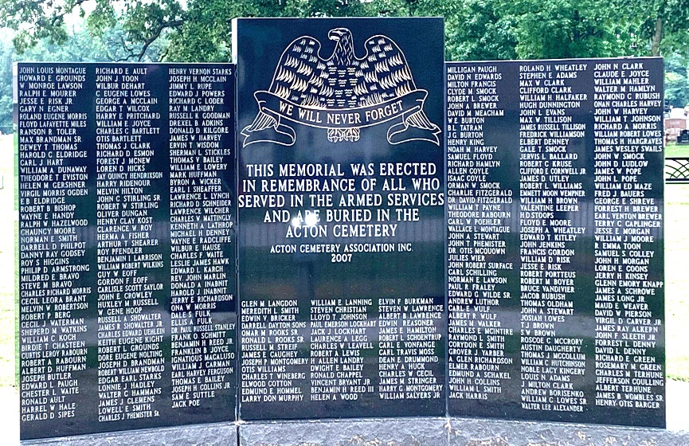

**Clothing Pantry**

Open Thursdays 2:00 pm – 5:00 pm

*Closed on the 5th Thursday.



There are over 400 Veterans buried in the Cemetery and on the memorial.

Acton Cemetery Memorial Day Service

The Acton Cemetery is planning to hold their annual Memorial Day Service on Monday, May 31st at 1:00 p.m. The program will be held by the Veteran’s Memorial at the front of the cemetery on Acton Road.

Steve Jeffris will be the Master of Ceremonies and the Boy Scouts will raise a new American Flag. The Indy Metropolitan Military Honor Guard, Inc. will provide their firing of the rifles and taps to conclude the program. Dave Morgan will pay a couple of songs on his trumpet.

Please bring your lawn chair and help us honor those who have served and those who paid the ultimate price for our country.

In case of rain, the service will be held across the street at the Acton Baptist Church.

**Worship Music Copyright and Live-Streaming Permissions**

**All selections ©1997 Word/Integrity Used by Permission.**

**CCLI License #1631733**

See hymns within the bulletin listed.

********************

“Wanderlust” by Jim Brickman

“Heartland by Jim Brickman

“Border” by Jim Brickman

“Rocket to the Moon” by Jim Brickman

“On Eagles Wings” by Jan Michael Joncas

“O Worship the King” by Robert Grant, William Gardener, Johann M. Haydn, Don Marsh

“Majesty” by Jack W. Hayford, Eugene Thomas

**Live-Streaming: CCS, WorshipCast, License #10868**

The American Baptist Women’s Ministries will be hosting a virtual Sisters in Prayer time this Thursday at 8:00 p.m. If you would like to join women from across the country and Puerto Rico in a time of prayer, please visit [www.abwomensministries.org](http://www.abwomensministries.org) for registration info.