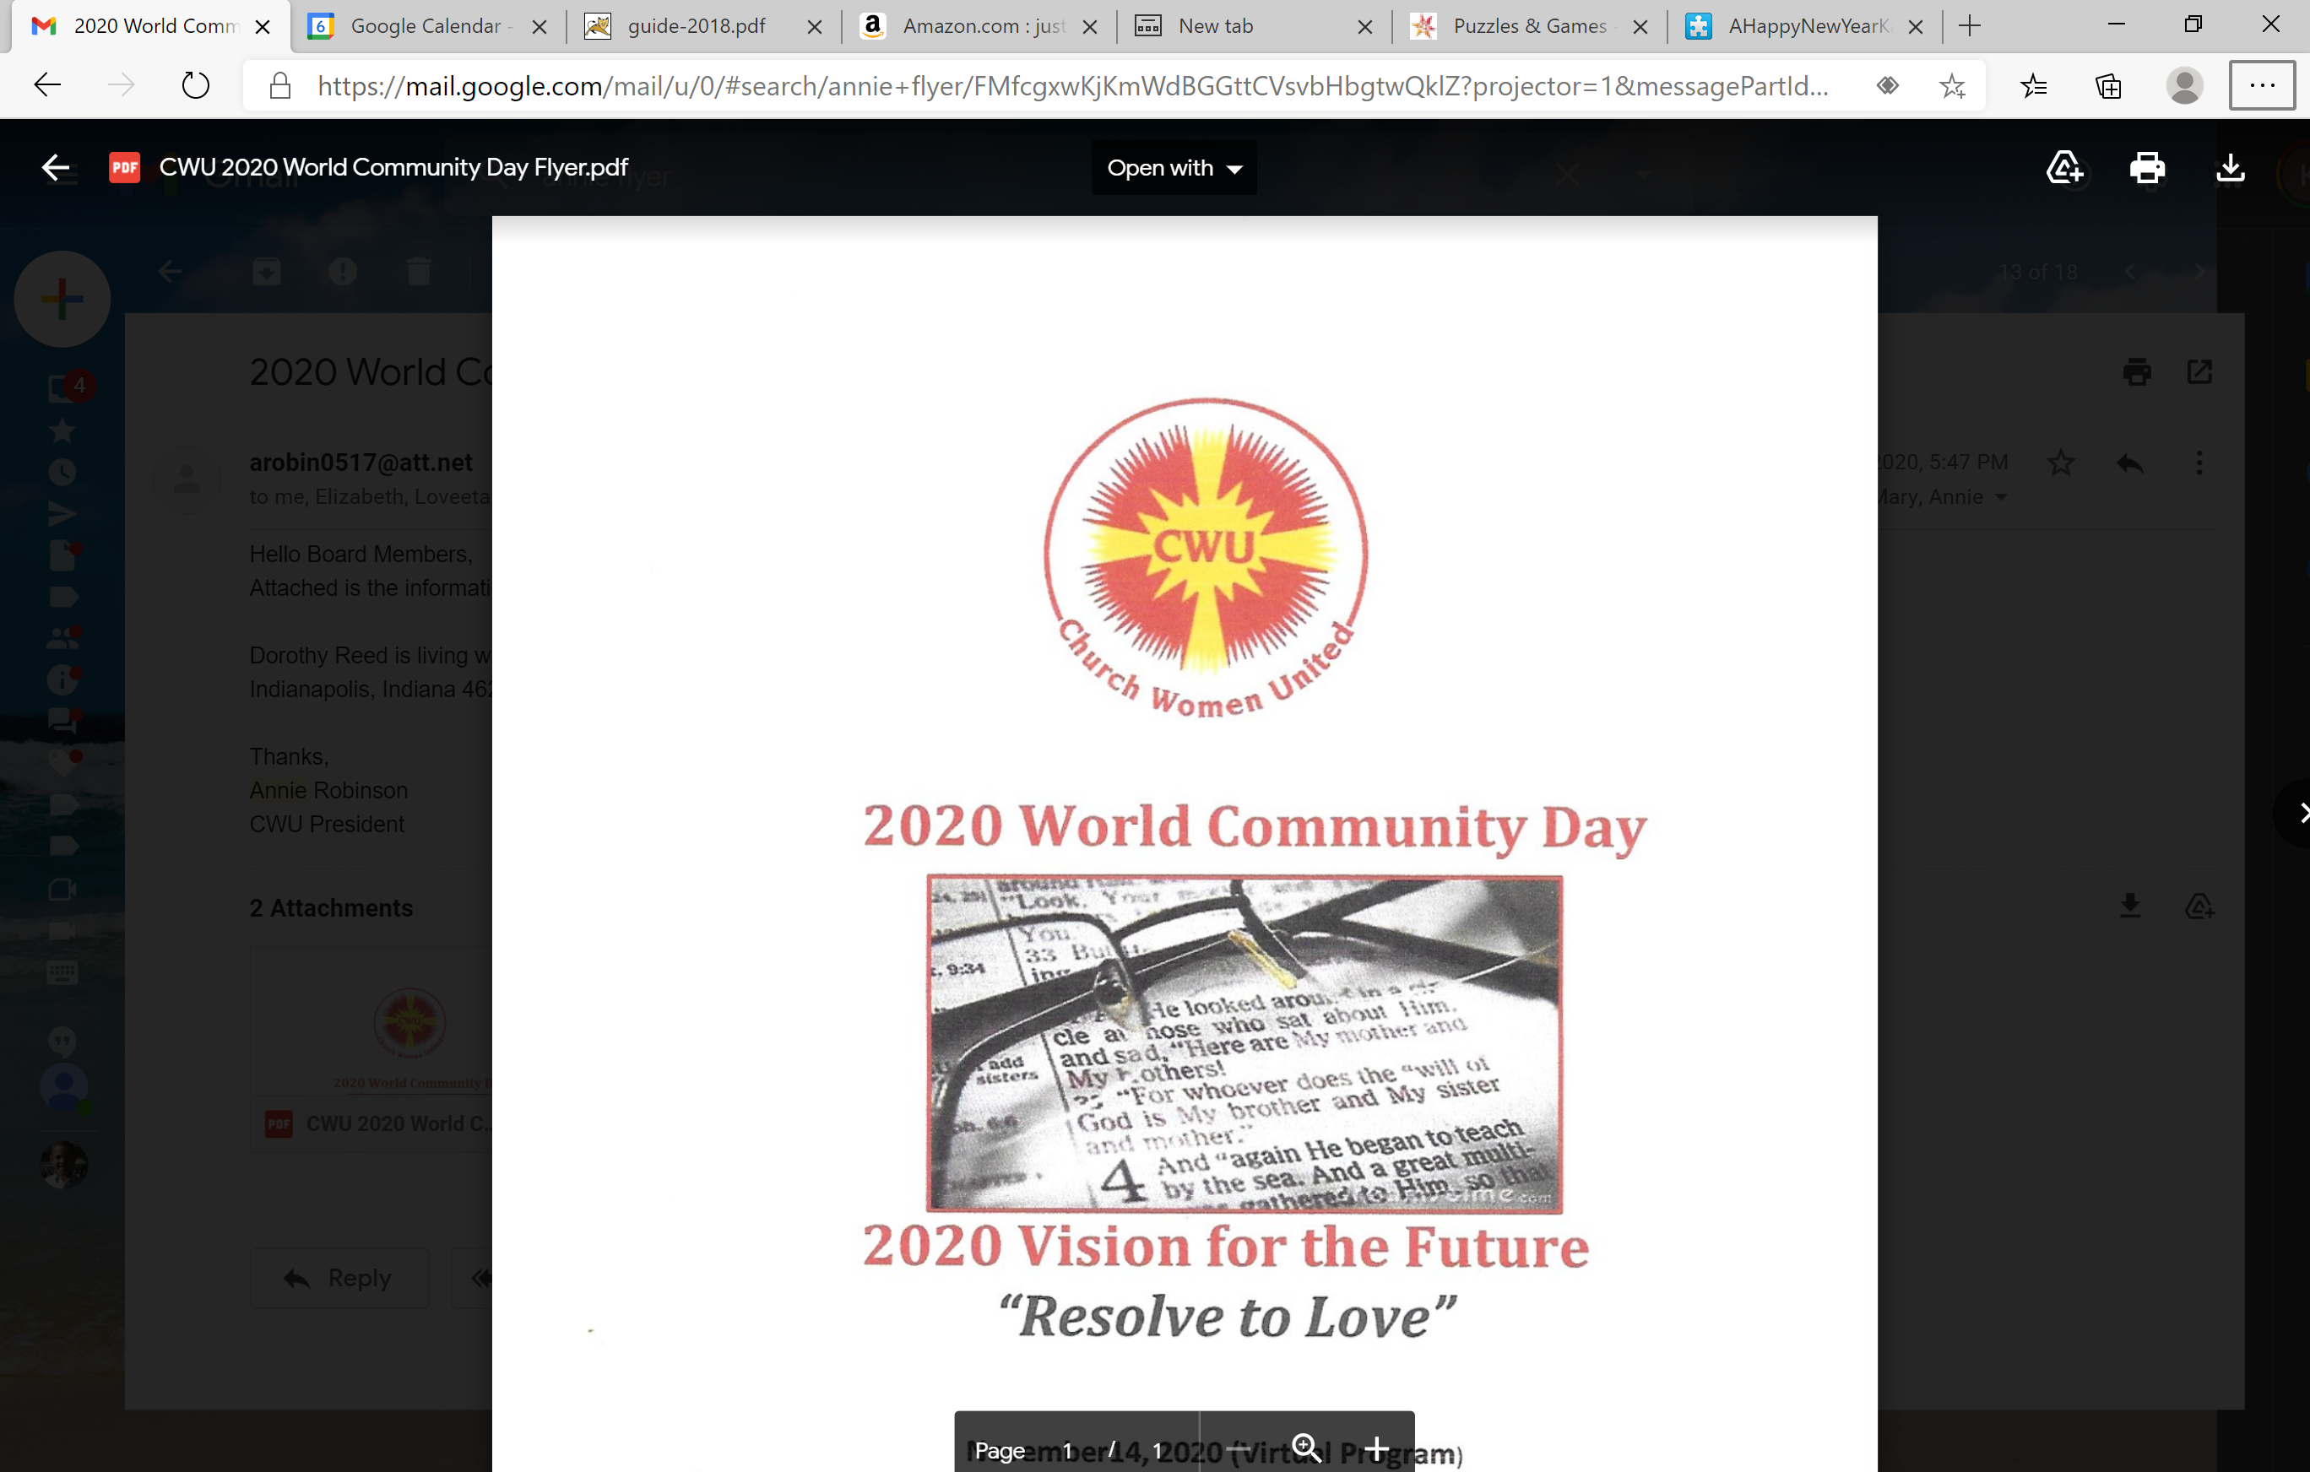

**Thursday, August 26 at 7 PM**

**Church Women United Zoom Webinar**

***The faith community must unite to drive for a safer Indy***

We must support efforts to ***reduce gun violence*** and insist on full commitment to proven strategies. Let’s join all our hearts and voices towards freedom from fear, helping those at high risk of violence find different paths and redemption.

Zoom meeting – click on the following link:

<https://us02web.zoom.us/j/85350254545?pwd=dGJDbmYvWUxyQWVnODd6bWFLdzZvQT09>

By phone: 312 626 6799, Meeting ID: 853 5025 4545, Passcode: 010931

**Awareness, Education, Connections!** – build a united community voice that can help make a difference for our neighbors and our city

**Learn about:**

* the complexity of gun violence, root causes, and the broad range of solutions needed
* the specific nature of street violence and the proven strategy available to reduce it.
* some of the current efforts and resources to share and join

**Includes:**

* Video of ‘Cease Fire strategy from national consultant on gun violence Intervention
* OPHS – Communications Director – Caroline Ellert
* Faith In Indiana lead organizer –

Rosie Bryant

* Stand Up for a United Indy leader –

Matt Steward

**Any questions please contact Karen Walker at 317-319-8950**