**Welcome to New Bethel Baptist Church**

*Sunday* November 21, 2021

**Prelude** Dr. Christina Romero

**Gathering Song** *Here I Am To Worship*

*The Heart of Worship*

**\*Call to Worship**

*One:  Come together and worship the Lord.*

**Many:  We gather to offer praise to our God.**

*One:  We give thanks to our God, who has created us.*

**Many:  We give thanks to our God who has saved us.**

**All: We give thanks to our God who has saved us from sin and redeemed us for life.**

**\*Invocation and Lord’s Prayer (***using “sins”*) Jim Winton

**\*Hymn** *We Gather Together #790*

**Scripture Reading** 1 Samuel 15:24-34 Jim Winton

**Worship Prayer** Tom Bartley

*Family of God #419*

**\*Hymn** *Come Ye Thankful People Come #797*

**Children’s Message**

**Scripture Reflection** Colossians 3:15-17Tom Bartley

**\*Hymn** *Count Your Blessings #786*

**Ministry Opportunities** Jim Winton

*Offertory Dr. Christina Romero

*Doxology #815

*Prayer

**Benediction**  Tom Bartley

**Postlude**  Dr. Christina Romero & Phil Morgan

*\*\*\*\*\*\*\*\*\*\*\*\*\*\*\*\**

**Happening This Week**

Today 10:30 a.m. Live-stream and In-Person Sunday Worship

Wednesday 11:00 a.m., Zoom Book discussion, *Dangerous Wonder,* contact Janie Bryant

6:00 -7:00 p.m. God’s Bounty accepts donations

Thursday 1:00 -7:00 p.m. God’s Bounty serves community

2:00 -5:00 p.m. Clothing Pantry (closed on 5th Thursday)

*\*\*\*\*\*\*\*\*\*\*\*\*\*\*\*\*\*\*\*\**

**Week Ahead**

Sunday November 28th 10:30 a.m. Worship

*\*\*\*\*\*\*\*\*\*\*\*\*\*\*\*\*\*\*\*\**

**Daily Prayer Calendar**

**Sunday, November 21, 2021:** 2 Samuel 23:1-7; Psalm 132:1-12 [13-18]; Revelation 1:4b-8; John 18:33-37

**Monday, November 22, 2021**: Psalm 63; 2 Kings 23:15-25; Revelation 11:1-14

**Tuesday, November 23, 2021**: Psalm 63; 1 Samuel 17:55-18:5; Revelation 11:15-19

**Wednesday, November 24, 2021**: Psalm 63; 2 Samuel 2:1-7; John 16:25-33

**Thursday, November 25, 2021**: Psalm 25:1-10 ; Nehemiah 9:6-15; Thessalonians 5:1-11

**Friday, November 26, 2021**: 25:1-10; Nehemiah 9:16-25; Thessalonians 5:12-22

**Saturday, November 27 , 2021**: Psalm 25:1-10; Nehemiah 9:26-31; Luke 21:20-24

*\*\*\*\*\*\*\*\*\*\*\*\*\*\*\*\*\*\*\*\*\**

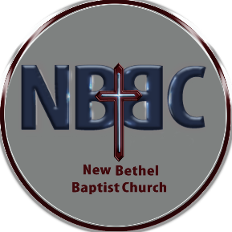

**WELCOME TO NEW BETHEL BAPTIST CHURCH**

**We are blessed by your presence!**

**GUEST AND MEMBERS:** If you have questions or would like more information about New Bethel, please feel free to contact the church office. Thank you!

*An American Baptist*

*Congregation*

**\*\*\*\*\*\***

Connect With Us

New Bethel Baptist.Wanamaker

nbbc.wanamaker

New Bethel Baptist Church Wanamaker



[This Photo](http://www.pngall.com/facebook-png) by Unknown Author is licensed under [CC BY-NC](https://creativecommons.org/licenses/by-nc/3.0/)



[This Photo](https://www.android4ar.com/%D8%AA%D8%AD%D8%AF%D9%8A%D8%AB-instagram-%D8%A7%D9%86%D8%AF%D8%B1%D9%88%D9%8A%D8%AF-%D9%8A%D8%AC%D9%84%D8%A8-%D8%A7%D9%84%D9%85%D9%84%D8%B5%D9%82%D8%A7%D8%AA-%D9%88%D8%A7%D9%84%D9%81%D9%8A%D8%AF%D9%8A/) by Unknown Author is licensed under [CC BY-NC](https://creativecommons.org/licenses/by-nc/3.0/)



[This Photo](https://commons.wikimedia.org/wiki/File:YouTube_social_white_square_(2017).svg) by Unknown Author is licensed under [CC BY-SA](https://creativecommons.org/licenses/by-sa/3.0/)

**********************

**CONTACT INFORMATION**

New Bethel Baptist Church **Website:** www.newbethelbapt.org

8936 Southeastern Avenue **E-mail:** newbethelbapt@att.net Indianapolis, IN 46239 **Wi-fi password:** NBBC8624381

317-862-4381

Rev. Tom Bartley, Interim Pastor

Julianne Thomas, Minister of Administration

Dr. Christina Romero, Pianist

**Worship Music Copyright and Live-Streaming Permissions**

**All selections ©1997 Word/Integrity Used by Permission.**

**CCLI License #1631733**

**Live-Streaming: CCS, WorshipCast, License #10868**

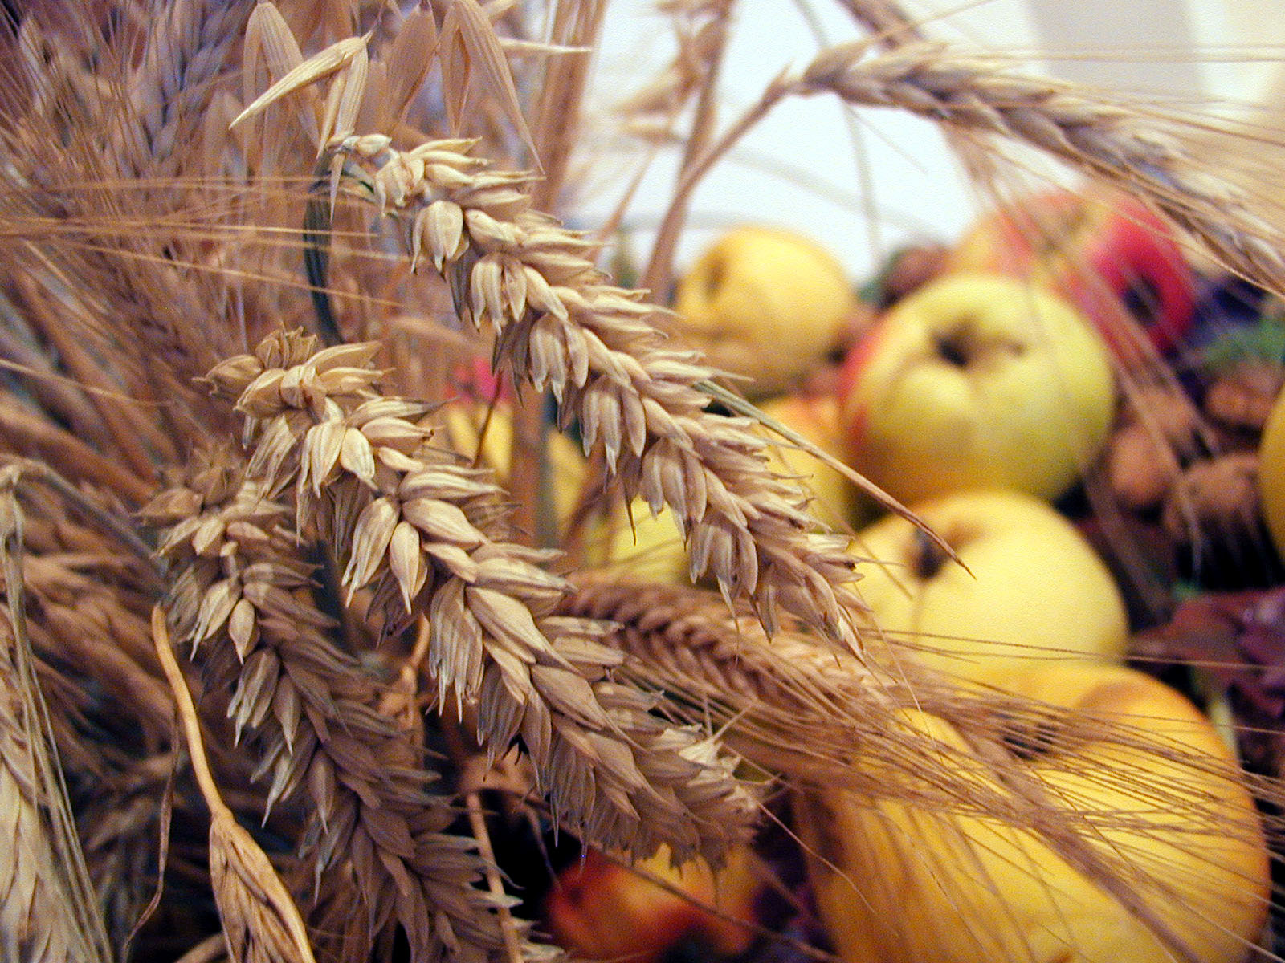

O give thanks to the Lord, for he is good;

for God’s steadfast love endures forever.

1 Chronicles 16:34

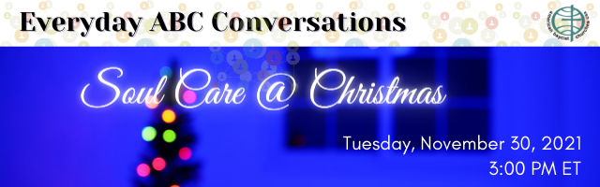

Tuesday, November 30, at 3:00pm ET – Zoom Platform

How is your soul as we enter this season of Advent and the celebrations associated with all of the expectations that the Christmas holidays bring?

Are you joyful, full of expectation, or are you weighted down with disappointment, grief and loss incurred during the pandemic? Are you numb, emotionally spent from living from one world and/or situational crisis to another?

We invite you to join in an inactive time of soul care on Tuesday, November 30 from 3:00-4:00pm (ET). It will be a time to re-discover the promise of the joys and expectations inherent in the good news of the Christ that tabernacles with us.

Rev. Judy Fackenthal and Rev. Betty Wright-Riggins, both spiritual directors and part of the ABCUSA Spiritual Direction Team, will walk with us as we explore the shimmering gifts of Advent and the promises therein.

No fee to participate, but online registration is required.

If you would like the online link to register, please contact Julianne via text or e-mail to have the link sent to you.

**God’s Bounty Food Pantry**

*Recipient of Meijer’s Fall Simply Give Campaign*

**When:** October 3, 2021 – January 1, 2022

**What:** Meijer will match every $10.00 donation made at their store.

Double Match Days: November 7-November 25th

Saturday December 11, 2021- Meijer will match every $10.00 donation on this date with a $20.00 donation.

**Where:** Southport Meijer

5325 E Southport Rd.

Indianapolis, IN 46237

**How:** Find the Simply Give kiosks near the front of the store. Take a card to the check out to be scanned. Meijer tracks the donations. You keep the card for your records.

NBBC has really supported this community mission and we can help make this an awesome fund raiser for the food pantry. As we go into this special time of year, please give to help our community. Let’s give glory to God because He has blessed us.



**Chili Supper**

We will once again be hosting our Annual Chili Supper:

**Saturday December 4, 2021**

**4:00 – 6:00 p.m.**

If you would like to help prepare, serve, or clean up please contact Kevin Stone.

Remember to invite your friends and family for some yummy chili!

**Faith Full Feeds**

Please visit this new spiritual growth website created by Phyllis Goodyear and ABCGI region staff member Jan Goodyear.

[*https://faithfullfeeds.weebly.com*](https://faithfullfeeds.weebly.com)

The life of faith is often described as a journey. At different points, we discover how faith intersects with life. We learn by feasting on familiar passages of scripture, devotional writings, and other sources of knowledge which enable us to discover a whole new meaning behind them.

On the website are playlists, a gathering of resources for you to feast on. You can visit the playlists for just a few minutes a day, working through the items one at a time, in any order, or you can work your way through the whole playlist at once.

You can enhance your experience by exploring the sections with a friend or family member, sharing your ideas ​and insights together.

*American Baptist Churches of Greater Indianapolis is Seeking Help*

**Do you like history?** On October 13, 1826, eight churches gathered to form the association now known as American Baptist Churches of Greater Indianapolis. We’d love some volunteers to dig through our archives to prepare for our 200th anniversary five years from now. If you’d enjoy being a part of a history team, please contact [*Mae*](mailto:office@abcgi.org) in our office.

(317)484-9327 or office@abcgi.org