**Welcome to New Bethel Baptist Church**

*Third Sunday After Epiphany January 23, 2022*

**Prelude** Dr. Christina Romero

**Gathering Song** *Your Grace Is Enough*

10,000 Reasons

**\*Invocation and Lord’s Prayer (using “sins”)**  Janie Bryant

**\*Call to Worship** Janie Bryant

*One: Great are you, our Lord, for you have created us!*

**Many: We Sing the song of creation this day!.**

*One: Great is the Lord, the One who has redeemed us!*

**Many: You have paid the price for our existence. We are Yours.**

*One: Great is the Lord who continues to sustain us!*

**Many: Your blessings continue to this day! Great is our God!.**

**\*Hymn** *Open My Eyes That I May See* #563

**Scripture Reading**  1 Samuel 17:17-27 Janie Bryant

**Worship Prayer** Tom Bartley

*Cares Chorus*

**\*Hymn** *Fairest Lord Jesus (vs 1, 3, 4)* #87

**Children’s Message**

**Scripture Reflection** Genesis 14:17-20 Tom Bartley

**\*Hymn** *There Shall Be Showers of Blessing* #430

**Ministry Opportunities** Janie Bryant

**Offertory** Dr. Christina Romero **\*Doxology**

**\*Prayer** Janie Bryant

**Benediction**  Tom Bartley

**Postlude**  Dr. Christina Romero

*\*\*\*\*\*\*\*\*\*\*\*\*\*\*\*\**

**Happening This Week**

Today 10:30 a.m. Live-stream and In-Person Sunday Worship

Wednesday 11:00 a.m., Zoom Book discussion, *The Gifts of Imperfection* by Brene Brown*,* contact Janie Bryant

6:00 -7:00 p.m. God’s Bounty accepts donations

Thursday 1:00 -7:00 p.m. God’s Bounty serves community

2:00 -5:00 p.m. Clothing Pantry (closed on 5th Thursday)

*\*\*\*\*\*\*\*\*\*\*\*\*\*\*\*\*\*\*\*\**

**Upcoming**

Sunday January 30th 10:30 a.m. Worship

Sunday February 6th 12:00 Annual Meeting

*\*\*\*\*\*\*\*\*\*\*\*\*\*\*\*\*\*\*\*\**

**Daily Prayer Calendar**

**Sunday, January 23, 2022:** Nehemiah 8:1-3, 5-6, 8-10; Psalm 19; 1 Corinthians 12:12-31a; Luke 4:14-21

**Monday, January 24, 2022**: Jeremiah 36:1-10; 1 Corinthians 14:1-12; Psalm 119:89-96

**Tuesday, January 25, 2022**: Jeremiah 36:11-26; 2 Corinthians 7:2-12; Psalm 119:89-96

**Conversion of Paul:** Acts 9:1-22; Psalm 67; Galatians 1:11-24; Luke 21:10-19

**Wednesday, January 26, 2022**: Jeremiah 36:27-32; Luke 4:38-44; Psalm 119:89-96

**Thursday, January 27, 2022**: 2 Chronicles 34:1-7; Acts 10:44-48; Psalm 71:1-6

**Friday, January 28, 2022**: 2 Chronicles 35:20-27; Acts 19:1-10; Psalm 71:1-6

**Saturday, January 28, 2022**: 2 Chronicles 36:11-21; John 1:43-51; Psalm 71:1-6

*\*\*\*\*\*\*\*\*\*\*\*\*\*\*\*\*\*\*\*\*\**

**WELCOME TO NEW BETHEL BAPTIST CHURCH**

**We are blessed by your presence!**

**GUEST AND MEMBERS:** If you have questions or would like more information about New Bethel, please feel free to contact the church office. Thank you!

*An American Baptist*

*Congregation*

**\*\*\*\*\*\***

Connect With Us

New Bethel Baptist.Wanamaker

nbbc.wanamaker

New Bethel Baptist Church Wanamaker



[This Photo](http://www.pngall.com/facebook-png) by Unknown Author is licensed under [CC BY-NC](https://creativecommons.org/licenses/by-nc/3.0/)



[This Photo](https://www.android4ar.com/%D8%AA%D8%AD%D8%AF%D9%8A%D8%AB-instagram-%D8%A7%D9%86%D8%AF%D8%B1%D9%88%D9%8A%D8%AF-%D9%8A%D8%AC%D9%84%D8%A8-%D8%A7%D9%84%D9%85%D9%84%D8%B5%D9%82%D8%A7%D8%AA-%D9%88%D8%A7%D9%84%D9%81%D9%8A%D8%AF%D9%8A/) by Unknown Author is licensed under [CC BY-NC](https://creativecommons.org/licenses/by-nc/3.0/)



[This Photo](https://commons.wikimedia.org/wiki/File:YouTube_social_white_square_(2017).svg) by Unknown Author is licensed under [CC BY-SA](https://creativecommons.org/licenses/by-sa/3.0/)

**********************

**CONTACT INFORMATION**

New Bethel Baptist Church **Website:** www.newbethelbapt.org

8936 Southeastern Avenue **E-mail:** newbethelbapt@att.net Indianapolis, IN 46239 **Wi-fi password:** NBBC8624381

317-862-4381

Rev. Tom Bartley, Interim Pastor

Julianne Thomas, Minister of Administration

Dr. Christina Romero, Pianist

**Worship Music Copyright and Live-Streaming Permissions**

**All selections ©1997 Word/Integrity Used by Permission.**

**CCLI License #1631733**

**Live-Streaming: CCS, WorshipCast, License #10868**

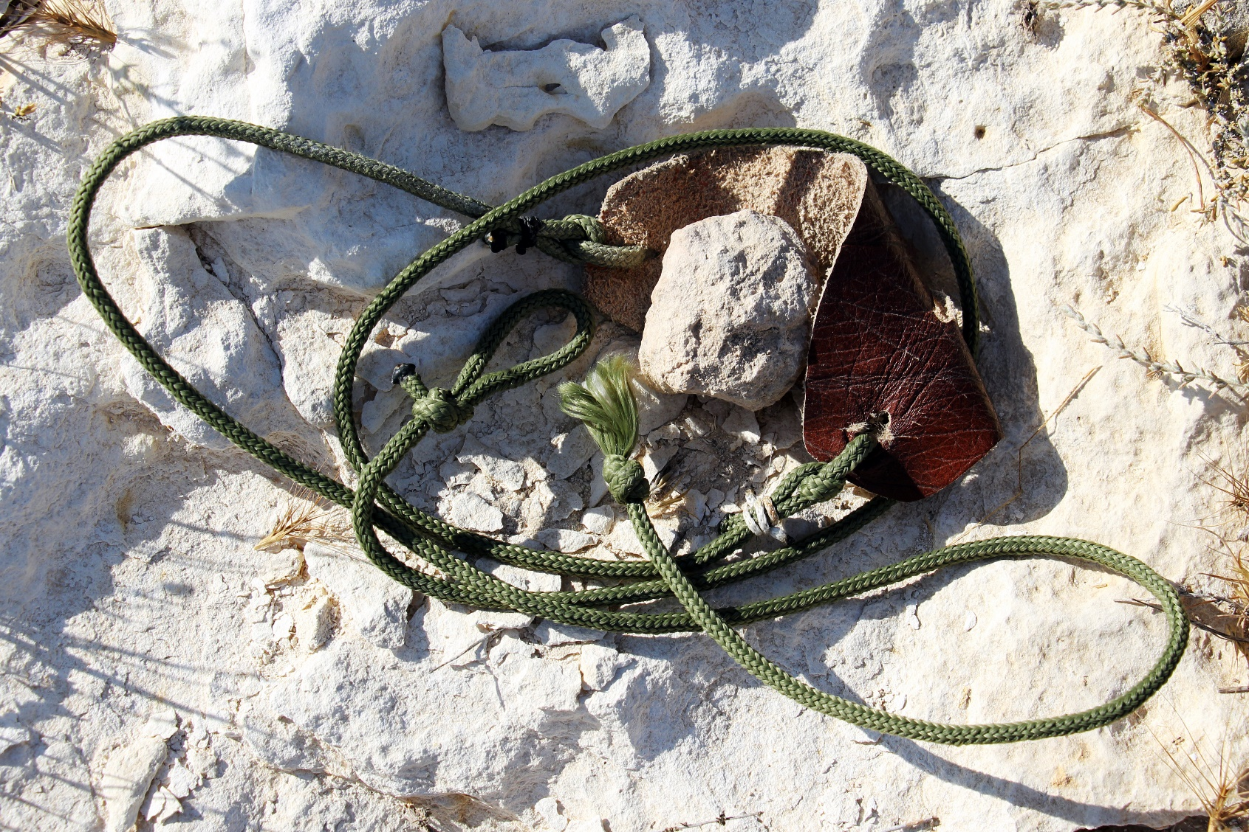

**Transformed by Generosity**

***Retired Ministers & Missionaries Offering***

During the month of January, we are collecting a special offering to thank our retired ministers and missionaries. The goal for New Bethel is to collect ***$500.00*** to show our gratitude for those who answered God’s call to share the love of Christ Jesus with our communities and the world.

Special envelopes are on the tables with the bulletins, or you can indicate Retired Ministers and Missionaries on the memo line of a check.

“So all of us who have had that veil removed can see and reflect the glory of the Lord. And the Lord – who is the Spirit – makes us more and more like the Creator as we are changed into the Divine’s glorious image.” 2 Corinthians 3:18

**Offering Envelopes**

If you are needing offering envelopes, please let the church office know via e-mail or putting this form in the offering plate. Please be sure to include the following information.

Name:__________________________________________

Envelope Number:_________________________________

How many you need:

52 envelopes:__________

12 envelopes:___________

I will get these to you as soon as possible.

Julianne

**Sermon Notes**

Wanting to take sermon notes but forgot to bring a notebook? You can use this space to take notes of the sermon. Write down questions you may have, new insights, or additional thoughts you may have from the sermon.

* ________________________________________________________________________________________________________________________________________________________________________________________________________________________________________________________________________________________________________________________________________________________________________________________________________________________________________________________________________________________________________________________________________________________________________________________________________________________________________________________________________________________________________________________________________________________________________________________________________________________________________________________________________________________________________________________________________________________________________________________________________________________________________________________________________________________________________________________________________________________________________________________________________________________________________________________________________________________________________________________________________________________________________________________________________________________________________________________