**Welcome to New Bethel Baptist Church**

*Sixth Sunday in Lent, Palm Sunday, April 10, 2022*

**Prelude** Dr. Christina Romero

**Gathering Song** *Fairest Lord Jesus #87*

**\*Invocation and Lord’s Prayer (using “sins”)** Sue Winton

**Lenten Moment** Sue Winton

**\*Hymn** *We Have Come Into His House #224*

**Scripture Reading**  2 Samuel 1:1-16 Sue Winton

**Worship Prayer** Tom Bartley

*Cares Chorus*

**\*Hymn** *Praise to the Lord, the Almighty #210*

**Youth & Children’s Message**

**Scripture Reflection** Luke 19:28-44 Tom Bartley

**\*Hymn** *My Savior’s Love #348*

**Ministry Opportunities** Sue Winton

**Offertory** Dr. Christina Romero **\*Doxology**

**\*Prayer** Sue Winton

**Benediction**  Tom Bartley

**Postlude**  Dr. Christina Romero

*\*\*\*\*\*\*\*\*\*\*\*\*\*\*\*\**

**Happening This Week**

Today 10:30 a.m. Live-stream and In-Person Sunday Worship

Wednesday 6:00 -7:00 p.m. God’s Bounty accepts donations

Thursday 11:00 a.m., Zoom Book discussion, *The Gifts of Imperfection* by Brene Brown*,* contact Janie Bryant

1:00 -7:00 p.m. God’s Bounty serves community

2:00 -5:00 p.m. Clothing Pantry (closed on 5th Thursday)

Saturday 10:00 – 11:30 p.m. Easter Egg Hunt

*\*\*\*\*\*\*\*\*\*\*\*\*\*\*\*\*\*\*\*\**

**Upcoming**

Today 10:30 Worship

Mother and Other Planning Meeting after Church

Thursday April 14th 7:00 p.m. Maundy Thursday Service

Saturday April 16th 10:00 a.m. Easter Egg Hunt

Sunday April 17th 10:30 Easter Sunday Worship

*\*\*\*\*\*\*\*\*\*\*\*\*\*\*\*\*\*\*\*\**

**Daily Scripture Readings**

Please see the insert for the daily scripture readings and prayers for Holy Week.

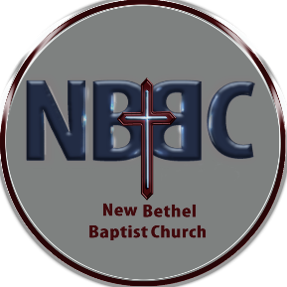**WELCOME TO NEW BETHEL BAPTIST CHURCH**

**We are blessed by your presence!**

**GUEST AND MEMBERS:** If you have questions or would like more information about New Bethel, please feel free to contact the church office. Thank you!

*An American Baptist*

*Congregation*

**\*\*\*\*\*\***

Connect With Us

New Bethel Baptist.Wanamaker

nbbc.wanamaker

New Bethel Baptist Church Wanamaker



[This Photo](http://www.pngall.com/facebook-png) by Unknown Author is licensed under [CC BY-NC](https://creativecommons.org/licenses/by-nc/3.0/)



[This Photo](https://www.android4ar.com/%D8%AA%D8%AD%D8%AF%D9%8A%D8%AB-instagram-%D8%A7%D9%86%D8%AF%D8%B1%D9%88%D9%8A%D8%AF-%D9%8A%D8%AC%D9%84%D8%A8-%D8%A7%D9%84%D9%85%D9%84%D8%B5%D9%82%D8%A7%D8%AA-%D9%88%D8%A7%D9%84%D9%81%D9%8A%D8%AF%D9%8A/) by Unknown Author is licensed under [CC BY-NC](https://creativecommons.org/licenses/by-nc/3.0/)



[This Photo](https://commons.wikimedia.org/wiki/File:YouTube_social_white_square_(2017).svg) by Unknown Author is licensed under [CC BY-SA](https://creativecommons.org/licenses/by-sa/3.0/)

**********************

**CONTACT INFORMATION**

New Bethel Baptist Church **Website:** www.newbethelbapt.org

8936 Southeastern Avenue **E-mail:** newbethelbapt@att.net Indianapolis, IN 46239 **Wi-fi password:** NBBC8624381

317-862-4381

Rev. Tom Bartley, Interim Pastor

Julianne Thomas, Minister of Administration

Dr. Christina Romero, Pianist

**Worship Music Copyright and Live-Streaming Permissions**

**All selections ©1997 Word/Integrity Used by Permission.**

**CCLI License #1631733**

**Live-Streaming: CCS, WorshipCast, License #10868**

**Easter Egg Hunt**

We will be having our Easter Egg Hunt on **Saturday, April 16th**. If you plan to help hide eggs, please arrive at 8:30.

The Egg Hunt festivities will start at 10:00 a.m. Invite your friends and family!

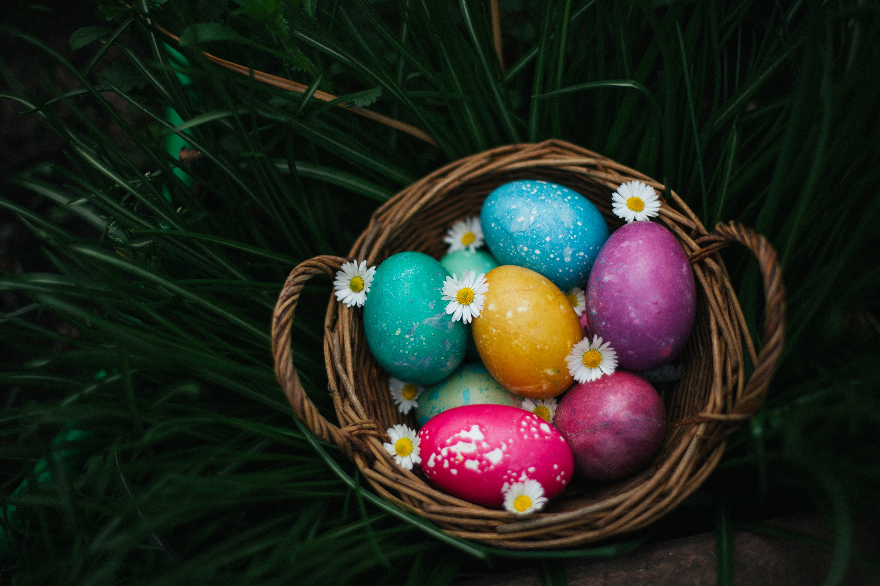

**Save The Date!**

**Monday, May 9th** at 6:00 p.m., we will be having our **Mother & Other Banquet**. We have missed being able to have this time to celebrate the women in our lives who make a difference and are excited to bring it back.

There will be a purse auction with lots of new purses. If you would like to donate a gently used purses, there will be a collection box set out. Tickets will go on sale soon!

Gentlemen, we are looking for male volunteers to help with serving the meal for the evening. If you wish to volunteer, please see Ruth Ann Mills.

Easter Flowers

Liz is now taking orders for Easter lilies, tulips, and hyacinths. Flowers are ***$12.50*** each.

If you would like to order a flower, please give your order and money or check to Liz Ballard. If you join us from online and would like to order a flower you may send your money/check to the church along with who you would like your flower to be in honor or memory of.

Lily: __________

Tulip: _________

Hyacinth: ________

In Honor/Memory of: ______________________________

___________________________________________________

Name of person ordering: _________________________

Total # of flowers: ______________

The last day to order your flowers is ***Today!***

**Holy Week Scripture Readings**

**Sunday of the Passion/ Palm Sunday, April 10, 2022:** Luke 19:28-40; Isaiah 50:4-9a; Psalm 31:9-16; Philippians 2:5-11; Luke 22:14-23:56; Luke 23:1-49

**Prayer of the Day**

**Everlasting God, in your endless love for the human race you sent our Lord Jesus Christ to take on our nature and to suffer death on the cross. If your mercy enable us to share in his obedience to your will and in the glorious victory of his resurrection, who lives and reigns with you and the Holy Spirit, one God, now and forever.**

*\*\*\*\*\*\*\*\*\*\*\*\*\*\*\*\*\*\*\*\*\*\*\*\*\*\*\*\*\*\**

**Monday in Holy Week, April 11, 2022**: Isaiah 42:1-9; Psalm 36:5-11; Hebrews 9:11-15; John 12:1-11

**Prayer of the Day**

**O God, your Son chose the path that led to pain before joy and to the cross before glory. Plant his cross in our hearts, so that in its power and love we May come at last to joy and glory, through Jesus Christ our Savior and Lord, who lives and reigns with you and the Holy Spirit, one God, now and forever.**

***\*\*\*\*\*\*\*\*\*\*\*\*\*\*\*\*\*\*\*\*\*\*\*\*\*\*\*\*\*\*\*\****

**Tuesday in Holy Week, April 12, 2022**: Isaiah 49:1-7; Psalm 71:1-14; 1 Corinthians 1:18-31; John 12:20-36

**Prayer of the Day**

Lord Jesus, you have called us to follow you. Grant that our love may not grow cold in your service, and that we may not fail or deny you in the time of trial, for you live and reign with the Father and the Holy Spirit, one God, now and forever.

*\*\*\*\*\*\*\*\*\*\*\*\*\*\*\*\*\*\*\*\*\*\*\*\*\*\*\*\*\**

**Wednesday in Holy Week, April 13, 2022**: Isaiah 50:4-9a; Psalm 70; Hebrews 12:1-3; John 13:21-32

**Prayer of the Day**

**Almighty God, your Son our Savior suffered at human hands and endured the shame of the cross. Grant that we May walk in the way of his cross and find it the way of life and peace, through Jesus Christ, our Savior and Lord, who lives and reigns with you and the Holy Spirit, one God, now and forever.**

***\*\*\*\*\*\*\*\*\*\*\*\*\*\*\*\*\*\*\*\*\*\*\*\****

**April 14, 2022- Maundy Thursday**: Exodus 12:1-4 [5-10] 11-14; Psalm 116:1-2, 12-19; 1 Corinthians 11:23-26; John 13:1-17, 31b-35

**Prayer of the Day**

Holy God, source of all love, on the night of his betrayal, Jesus gave us a new commandment, to love one another as he loves us. Write this commandment in our hearts, and give us the will to serve others as he was the servant of all, your Son, Jesus Christ, our Savior and Lord, who lives and reigns with you and the Holy Spirit, one God, now and forever.

**April 15, 2022- Good Friday**: Isaiah 52:13-53:12; Psalm 22; Hebrews 10:16-25; Hebrews 4:14-16, 5:7-9; John 18:1-19:42

**Prayer of the Day**

**Almighty God, look with loving mercy on your family, for whom our Lord Jesus Christ was willing to be betrayed, to be given over to the hands of sinners, and to suffer death on the cross; who now lives and reigns with you and the Holy Spirit, one God, forever and ever.**

*\*\*\*\*\*\*\*\*\*\*\*\*\*\*\*\*\*\*\*\*\*\*\*\*\**

**Saturday, April 16, 2022- Resurrection of Our Lord, Vigil of Easter**:

**Creation**: First Reading: Genesis 1:1-2:4a; Response: Psalm 136:1-9, 23-26

**Flood:** Second Reading: Genesis 7:1-5, 11-18, 8:6-18, 9:8-13;

**Response: Psalm 46**

**Testing of Abraham: Third Reading: Genesis 22:1-18; Response: Psalm 16**

**Deliverance at the Red Sea:** Fourth Reading: Exodus 14:10-31; 15:20-21;

**Response: Exodus 15:1b-13, 17-18**

**Salvation Freely Offered to All: Fifth Reading: Isaiah 55:1-11;**

**Response: Isaiah 12:2-6**

**The Wisdom of God: Sixth Reading: Proverbs 8:1-8, 19-21; 9:4b-6 or**

**Baruch 3:9-15, 32-4:4; Response: Psalm 19**

**A New Heart and a New Spirit: Seventh Reading: Ezekiel 36:24-28;**

**Response: Psalms 42 and 43**

**Valley of the Dry Bones: Eight Reading: Ezekiel 37:1-14; Response: Psalm 143**

**Gather of God’s People: Ninth Reading: Zephaniah 3:14-20; Response: Psalm 98**

**Call of Jonah: Tenth Reading: Jonah 1:1-2:1; Response Jonah 2:2-3 [4-6] 7-9**

**Clothed in the Garments of Salvation: Eleventh Reading: Isaiah 61:1-4, 9-11;**

**Response: Deuteronomy 32:1-4, 7, 36a, 43a**

**Deliverance from the Fiery Furnace: Twelfth Reading: Daniel 3:1-29;**

**Response: Psalm 148**

**New Testament Reading: Romans 6:3-11**

**Gospel: John 20:1-18**

**Prayer of the Day**

O God, you are the creator of the world, the liberator of your people, and the wisdom of the earth. By the resurrection of your Son free us from our fears, restore us in your image, and ignite us with your light, through Jesus Christ, our Savior and Lord, who lives and reigns with you and the Holy Spirit, one God, now and forever.

Source: https://www.elca.org/our-work/congregations-and-synods/worship/lectionary/yearc