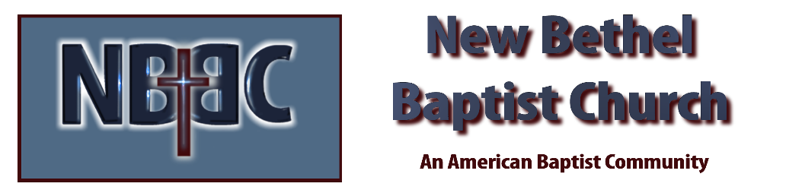

Maundy Thursday, April 14, 2022

Prelude

Lenten Candle Moment Sue Winton

*Hymn Lamb of God #302

Scripture Reading Matthew 26:14-16 Rev. Tom Bartley

Extinguishing of the First Candle

Scripture Reading Matthew 26:17-30 Sue Winton

Communion

Extinguishing of the Second Candle

*Hymn Jesus Paid It All #305

Scripture Reading Matthew 26:31-35 Rev. Tom Bartley

Scripture Reading Matthew 26:36-46 Sue Winton

*Hymn Hallelujah! What a Savior #311
Extinguishing of the Third Candle

Scripture Reading Matthew 26:47-56 Rev. Tom Bartley

Hymn What Wonderous Love is This? #314

Extinguishing of the Fourth Candle

Scripture Reading Matthew 26:57-68 Sue Winton

*Hymn Beneath the Cross of Jesus #320

Extinguishing of the Fifth Candle

Scripture Reading Matthew 26:69-75 Rev. Tom Bartley

Scripture Reading Matthew 27:1-10 Sue Winton

Hymn The Old Rugged Cross #327

Extinguishing of the Sixth Candle

Scripture Reading Matthew 27:11-26 Rev. Tom Bartley

Scripture Reading Matthew 27:27-44 Sue Winton

Extinguishing of the Seventh Candle

Special Music

Scripture Reading Matthew 27:45-54 Rev. Tom Bartley

Extinguishing of the Christ Candle

*As the Light from the Christ Candle is extinguished this service will draw to a close. There will be no benediction or postlude and you are asked to leave the sanctuary in silence.

**This service has ended but this is not the end of the story. We invite you to return with us on Sunday to once again celebrate the dramatic transformation of this story.

