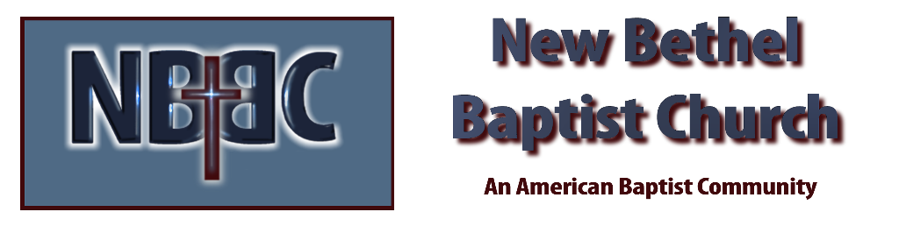

Sunday July 24, 2022

Prelude Rev. Judy Fackenthal

Gathering Song Build Your Kingdom Here

*Call To Worship Julianne Thomas
Many: God, who are we that you would be mindful of us?
One: You have been called by name. You have been redeemed at great cost.
Many: We grow old and weary. We are devastated by the suffering around us. We are overwhelmed by injustice.
One: Do not despair! For I am with you. My love is greater than the failings of the world. My compassion is enough to save.
Many: WE find new life in our Lord. We are renewed in the presence of the Living God.
All: We are here to worship the God who has saved us!

*Invocation and Lord’s Prayer (using “sins”) Julianne Thomas

*Hymn Worship Christ, the Risen King #361

Scripture Reading 2 Samuel 12:15-25 Julianne Thomas

Worship Prayer Cares Chorus Tom Bartley

*Hymn Freely, Freely #436

Youth and Children’s Message Julianne Thomas

Scripture Reflection Jonah 4:1-11 Tom Bartley

*Hymn Room at the Cross for You #487

Mission Moment Kevin Stone
Offertory Rev. Judy Fackenthal *Doxology
*Prayer Julianne Thomas

Benediction Tom Bartley
Postlude Rev. Judy Fackenthal

“The Lord replied, ‘Is it right for you to be angry about this?’”
Jonah 4:4 NLT

