**Welcome to New Bethel Baptist Church**

*Communion Sunday, Sunday July 3, 2022*

**Prelude** Dr. Christian Romero

**Gathering Song** *Come Thou Almighty King #8*

**\*Call To Worship**  Julianne Thomas

*One: We have been called by God.*

**Many: We hear the call and gather for worship.**

*One: God calls us to serve.*

**Many: We will serve our Lord and Savior.**

*One: The good news about God’s love is ours to share.*

**All: We will go where God calls us and share this good news.**

**\*Invocation and Lord’s Prayer (using “sins”)** Julianne Thomas

**\*Hymn** Praise to the Lord, the Almighty *#210*

**Scripture Reading** 2 Samuel 11:10-16 Julianne Thomas

**Worship Prayer** Tom Bartley

**\*Hymn** *There’s Something About That Name #83*

**Youth and Children’s Message** Julianne Thomas

**Scripture Reflection** Jonah 1:1-17 Tom Bartley

**\*Hymn** *I’ll Go Where You Want Me to Go #688*

**Ministry Opportunities** Julianne Thomas

**Offertory** Dr. Christina Romero **\*Doxology**

**\*Prayer** Julianne Thomas

**Communion Hymn**  *Come Share the Lord #462*

**Communion** Tom Bartley

**Benediction**  *Blest Be The Tie that Binds*

**Postlude**  Dr. Christian Romero

*\*\*\*\*\*\*\*\*\*\*\*\*\*\*\*\**

**Happening This Week**

Today 10:30 a.m. Live-stream and In-Person Sunday Worship

Wednesday 1:00- 3:00 p.m. Euchre Club (1st & 3rd Wednesday)

6:00 -7:00 p.m. God’s Bounty accepts donations

Thursday 1:00 -6:30 p.m. God’s Bounty serves community

Saturday 9:30 a.m. Yoga

1:00- 3:00 p.m. Euchre Club (3rd Saturday Only)

*\*\*\*\*\*\*\*\*\*\*\*\*\*\*\*\*\*\*\*\**

**Upcoming**

Sunday July 10th 10:30 Worship

Thursday July 14th Visit from Missionary Bruce Borquist

*\*\*\*\*\*\*\*\*\*\*\*\*\*\*\*\*\*\*\*\**

**Daily Scripture Readings**

**Sunday, July 3, 2022:** Isaiah 66:10-14; Psalm 66:1-9; Galatians 6:[1-6] 7-16; Luke 10:1-11, 16-20

**Prayer of the Day:** O God, the Father of our Lord Jesus, you are the city that shelters us, the mother who comforts us. With your Spirit accompany us on our life’s journey, that we may spread your peace in all the world, through your Son, Jesus Christ, our Savior and Lord.

**Monday, July 4, 2022:** Jermiah 6:10-19; Acts 19:21-27; Psalm 119:73-80

**Thomas, Apostle:** Judges 6:36-40; Psalm 136:1-4, 23-26; Ephesians 4:11-16; John 14:1-7

**Tuesday, July 5, 2022:** Jeremiah 8:4-13; Acts 19:28-41; Psalm 119:73-80

**Wednesday, July 6, 2022:** Joshua 23:1-16; Luke 10:13-16; Psalm 119:73-80

**Thursday, July 7, 2022:** Genesis 41:14-36; James 2:14-26; Psalm 25:1-10

**Friday, July 8, 2022:** Genesis 41:37-49; Acts 7:9-16; Psalm 25:1-10

**Saturday, July 9, 2022:** Leviticus 19:1-4, 32-37; John 3:16-21; Psalm 25:1-10

Source: Revised Common Lectionary as it appears in the Evangelical Lutheran Worship

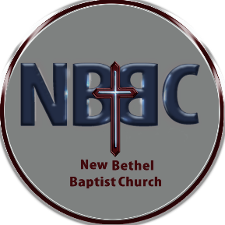**WELCOME TO NEW BETHEL BAPTIST CHURCH**

**We are blessed by your presence!**

**GUEST AND MEMBERS:** If you have questions or would like more information about New Bethel, please feel free to contact the church office. Thank you!

*An American Baptist*

*Congregation*

**\*\*\*\*\*\***

Connect With Us

New Bethel Baptist.Wanamaker

nbbc.wanamaker

New Bethel Baptist Church Wanamaker



[This Photo](http://www.pngall.com/facebook-png) by Unknown Author is licensed under [CC BY-NC](https://creativecommons.org/licenses/by-nc/3.0/)



[This Photo](https://www.android4ar.com/%D8%AA%D8%AD%D8%AF%D9%8A%D8%AB-instagram-%D8%A7%D9%86%D8%AF%D8%B1%D9%88%D9%8A%D8%AF-%D9%8A%D8%AC%D9%84%D8%A8-%D8%A7%D9%84%D9%85%D9%84%D8%B5%D9%82%D8%A7%D8%AA-%D9%88%D8%A7%D9%84%D9%81%D9%8A%D8%AF%D9%8A/) by Unknown Author is licensed under [CC BY-NC](https://creativecommons.org/licenses/by-nc/3.0/)



[This Photo](https://commons.wikimedia.org/wiki/File:YouTube_social_white_square_(2017).svg) by Unknown Author is licensed under [CC BY-SA](https://creativecommons.org/licenses/by-sa/3.0/)

**********************

**CONTACT INFORMATION**

New Bethel Baptist Church **Website:** www.newbethelbapt.org

8936 Southeastern Avenue **E-mail:** newbethelbapt@att.net Indianapolis, IN 46239 **Wi-fi password:** NBBC8624381

317-862-4381

Rev. Tom Bartley, Interim Pastor

Julianne Thomas, Minister of Administration

Dr. Christina Romero, Pianist

“But Jonah set out to flee to Tarshish from the presence of the Lord.”

Jonah 1:3a NRSV

**Worship Music Copyright and Live-Streaming Permissions**

**All selections ©1997 Word/Integrity Used by Permission.**

**CCLI License #1631733**

**Live-Streaming: CCS, WorshipCast, License #10868**

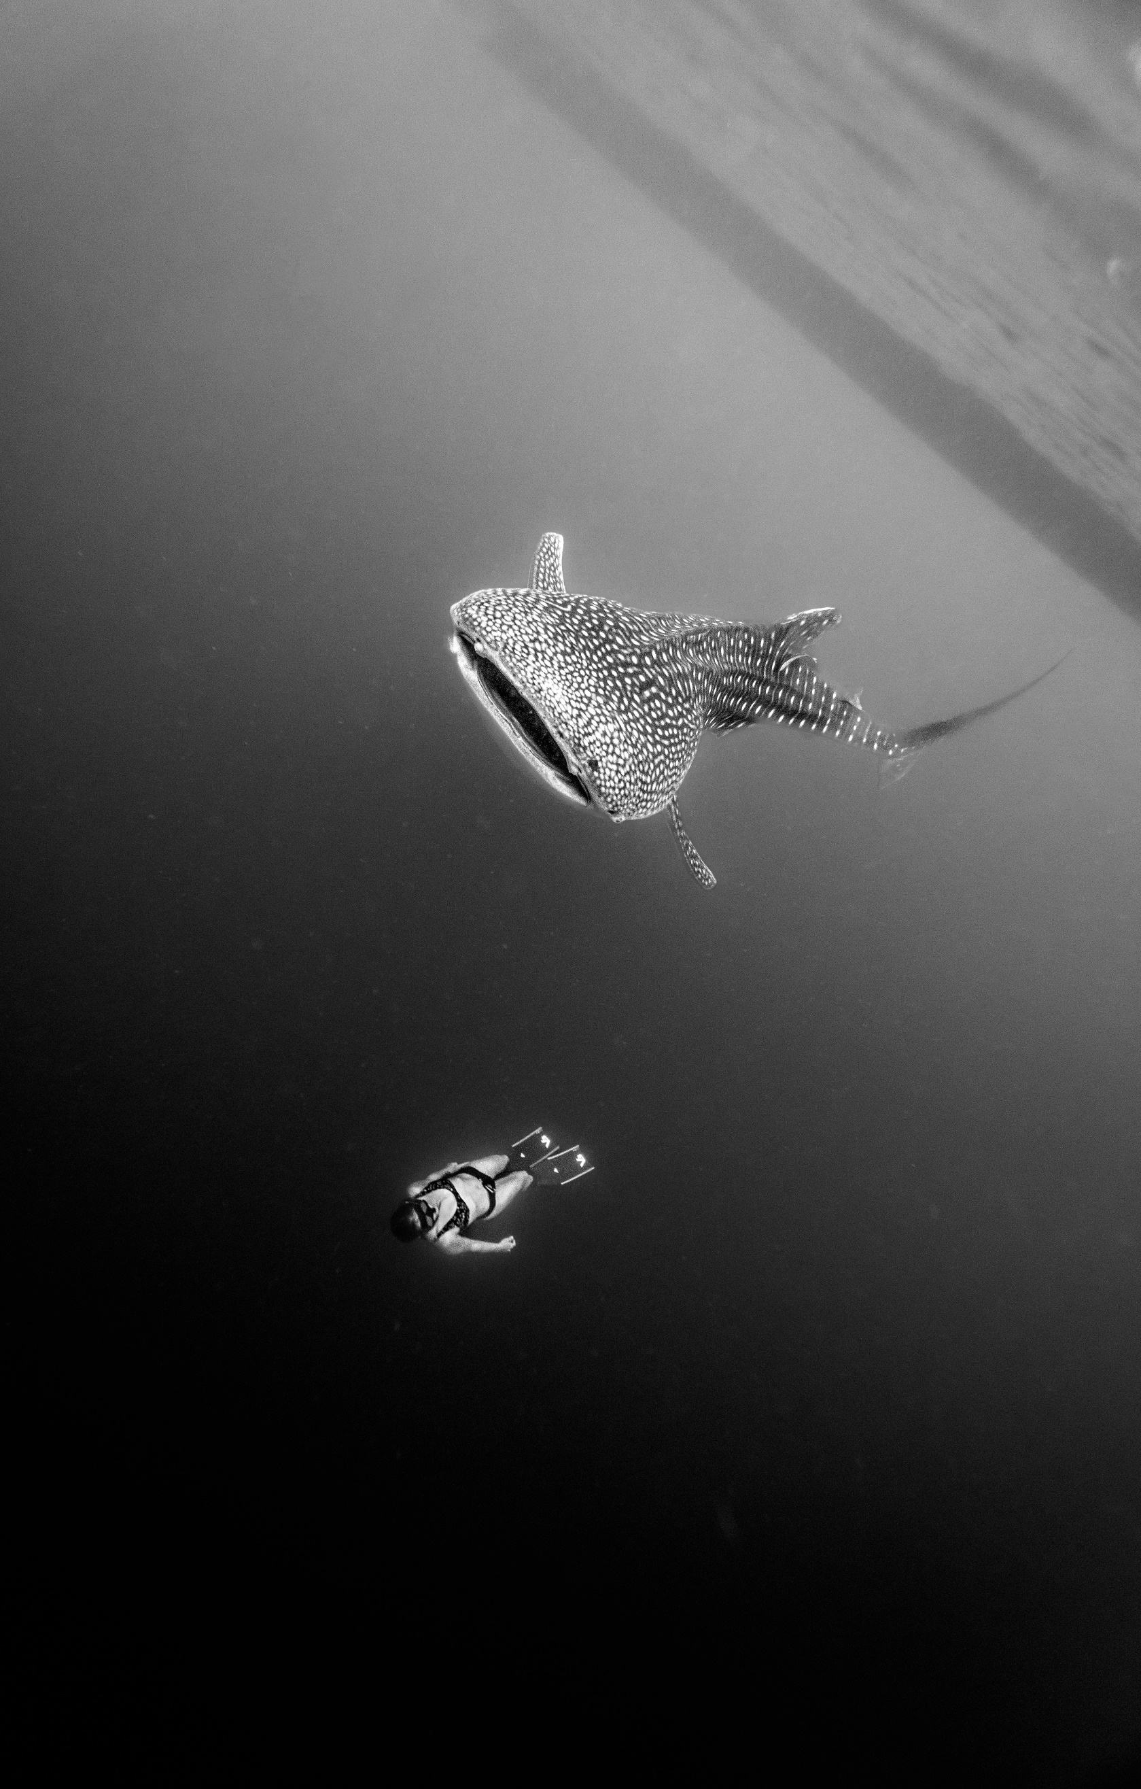

**Tech Coverage Needed**

We are needing two volunteers to cover the sound and video for Sunday July 17th. Rob will be taking that Sunday off. If you are interested in learning and helping, please see Rob Thomas.

**2022 Finances and Attendance Month of June Year-To-Date**

Tithes/Offerings                          $5,629.22 $54,952.70

Expenses Paid                           $6,393.85 $51,245.25

Gain/(Loss)                                    ($764.63) $3,707.45

Budget Needs                                 $11,515.00 $69,090.00

Average Weekly Worship Attendance 30

(At home and online)

**God’s Bounty Food Pantry**

God’s Bounty is one of our church’s community missions and serves families within the community with food and supplies to assist the families. With inflation and the costs of food continuing to increase, more families are in need and the costs to help them has increased. If you can help with food for the families, God’s Bounty Food Pantry would appreciate the help. Either leave donations on the table next to the office or deliver products to God’s Bounty on Wednesday evenings between 6:00 and 7:00. NBBC’s support of God’s Bounty Food Pantry continues to help make this community mission a success and is greatly appreciated.

A big” Thank You” to those individuals who help last month in serving client families. We continue to need VOLUNTEERS and the first week of the month is NBBC’s opportunity to volunteer. I am asking you to volunteer for one of the shifts on Thursday, 7 July. The shifts are 1-3, 3-5, and 5-6.:30. If you contact me we can discuss an opportunity that you feel comfortable in performing. Please contact me at (317) 862-6767 or at [KPY6767@att.net](mailto:KPY6767@att.net) if you can help out.