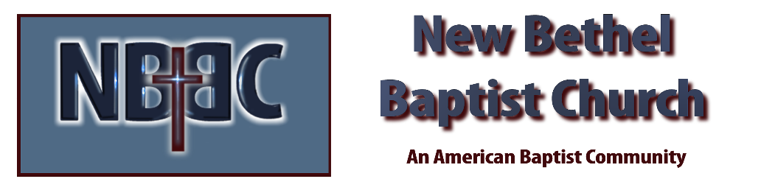

Sunday July 31, 2022

Prelude Dr. Christina Romero

Gathering Song Build Your Kingdom Here
Jesus Lover of My Soul

*Centering & Invocation Julianne Thomas

*Hymn As The Deer #548

Scripture Reading Psalm 24 Tom Bartley

Worship Prayer Cares Chorus Julianne Thomas

Blessing of the Backpacks Ruth Ann Mills
Leader: God, we come before you as another school year begins
People: We come to seek your protection and blessings for our students, parents, teachers, bus drivers, and school staff.
Leader: Divine Creator, who once came as a child to learn and grow, to be in and with your creation.
People: Protect and watch over our children. Keep them safe in body, heart, and mind. Help them to learn and grow in safe and healthy environments.
Leader: Holy Parent, who loves and cares for their children.
People: Give our parents peace of heart and mind as they send their children off to school, trusting in the care of others.
Leader: Heavenly Teacher, who guides us into the wisdom of love.
People: Be with our teachers, bus drivers, and staff. Protect them as they watch over our children. Grant them patience when working with challenging students and parents. Help them to find creative and meaningful ways to help our children learn.
Leader: God of the heavens and earth, we pray this school year be a time of growth, excitement, and connection.
People: Lord, bless our children, their families, the faculty, and staff in this new school year. Amen

*Hymn What A Friend We Have in Jesus #630

Spiritual Practice Julianne Thomas

*Hymn Sunshine in My Soul #747

Response to God
Offertory Dr. Christina Romero *Doxology
*Prayer Tom Bartley

Benediction Julianne Thomas
Postlude Dr. Christina Romero

CONTACT INFORMATION
New Bethel Baptist Church Website: www.newbethelbapt.org
8936 Southeastern Avenue E-mail: newbethelbapt@att.net Indianapolis, IN 46239 Wi-fi password: NBBC8624381
317-862-4381
Worship Music Copyright and Live-Streaming Permissions
All selections ©1997 Word/Integrity Used by Permission.
CCLI License #1631733

Live-Streaming: CCS, WorshipCast, License #10868

