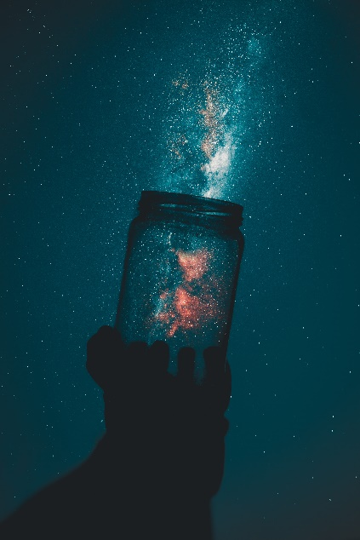

*Sunday August 14, 2022*

**Prelude** Dr. Christina Romero

**\*Gathering Song** *Blessed Be Your Name*

*I Lift My Hands*

**\*Call to Worship**

**Many: We have gathered to hear the story of creation.**

*One: God’s love led to the establishment of all the earth.*

**Many: The world is the example of God’s love in motion.**

*One: The heavens and the earth give testimony to the greatness of God.*

**All: Today we worship the Lord, Creator of the heavens and the earth, Master of all that has been, all that is, and all that will be. Amen.**

**\*Invocation & Lord’s Prayer (use “sins)** Julianne Thomas

**\*Hymn** *The Church’s One Foundation #401*

**Scripture Reading** 1 Kings 1:28-37 Julianne Thomas

**Worship Prayer** *Cares Chorus* Tom Bartley

**\*Hymn** *Glorify Thy Name #9*

**Youth and Children’s Message** Julianne Thomas

**Scripture Reflection** Genesis 1:14-19 Tom Bartley

**\*Hymn** *The Solid Rock #526*

**Response to God**

**Offertory** Dr. Christina Romero **\*Doxology**

**\*Prayer** Julianne Thomas

**Benediction**  Tom Bartley

**Postlude**  Dr. Christina Romero

**CONTACT INFORMATION**

New Bethel Baptist Church **Website:** www.newbethelbapt.org

8936 Southeastern Avenue **E-mail:** newbethelbapt@att.net Indianapolis, IN 46239 **Wi-fi password:** NBBC8624381

317-862-4381

**Worship Music Copyright and Live-Streaming Permissions**

All selections ©1997 Word/Integrity Used by Permission.

CCLI License #1631733

Live-Streaming: CCS, WorshipCast, License #10868