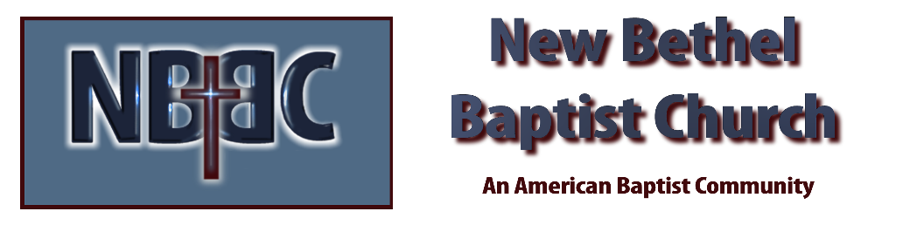

Sunday August 28, 2022

Prelude Dr. Christina Romero

*Gathering Song Majesty #10

*Call to Worship
One: Come and enter into the House of the Lord. Come and be renewed.
Many: For the Lord is at work in us. Recreating us into something new.
One: God has created all that has been made. And God remains present with all of creation.
Many: God is with us. God is for us.
One: Come and be remade into the very image of God.
All: We are the image of the Living God. Our love the echo of God’s Love in the world.

*Invocation & Lord’s Prayer (use “sins) Julianne Thomas

*Hymn All Hail the Power of Jesus Name #43

Scripture Reading 1 Kings 3:16-28a Julianne Thomas

Worship Prayer Cares Chorus Tom Bartley

*Hymn Joyful Joyful We Adore Thee #90

Youth and Children’s Message Julianne Thomas

Scripture Reflection Genesis 1:31b-2:3 Tom Bartley

*Hymn Higher Ground #549

Response to God
Offertory Dr. Christina Romero *Doxology
*Prayer Julianne Thomas

Benediction Tom Bartley
Postlude Dr. Christina Romero

CONTACT INFORMATION
New Bethel Baptist Church Website: www.newbethelbapt.org
8936 Southeastern Avenue E-mail: newbethelbapt@att.net Indianapolis, IN 46239 Wi-fi password: NBBC8624381
317-862-4381
Worship Music Copyright and Live-Streaming Permissions
All selections ©1997 Word/Integrity Used by Permission.
CCLI License #1631733

Live-Streaming: CCS, WorshipCast, License #10868

