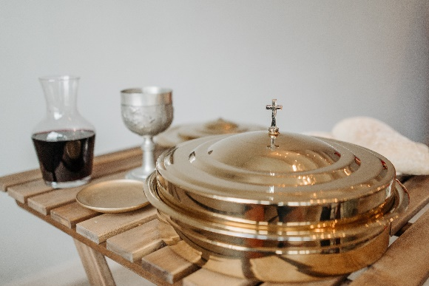

*Communion Sunday August 7, 2022*

**Prelude** Dr. Christina Romero

**\*Gathering Song** *Here I Am to Worship*

*How Great is Our God*

**\*Call to Worship**

*One: You are the Light of the World.*

**Many: We are called to let our light shine in the world.**

*One: God is the source of our light and our life. God calls us to worship.*

**Many: We are the reflection of God’s light shining into the world.**

*One: The light shines upon all creation.*

**All: Today Lord, let your light shine upon us. Let your light shine in us.**

**\*Invocation & Lord’s Prayer (use “sins)** Julianne Thomas

**\*Hymn** *All Creatures of Our God and King #548 (vs 1-3, 5)*

**Scripture Reading** 1 Kings 1:11-21 Julianne Thomas

**Worship Prayer** *Cares Chorus* Tom Bartley

**\*Hymn** *Seek Ye First #713*

**Youth and Children’s Message** Julianne Thomas

**Scripture Reflection** Genesis 1:1-5 Tom Bartley

**\*Hymn** *We’ll Understand Better By and By #771*

**Response to God**

**Offertory** Dr. Christina Romero **\*Doxology**

**\*Prayer** Julianne Thomas

**Communion Hymn**  *Let Us Break Bread Together #460*

**Communion** Tom Bartley

**Benediction**  *Blest Be the Tie That Binds*

**Postlude**  Dr. Christina Romero

**CONTACT INFORMATION**

New Bethel Baptist Church **Website:** www.newbethelbapt.org

8936 Southeastern Avenue **E-mail:** newbethelbapt@att.net Indianapolis, IN 46239 **Wi-fi password:** NBBC8624381

317-862-4381

**Worship Music Copyright and Live-Streaming Permissions**

All selections ©1997 Word/Integrity Used by Permission.

CCLI License #1631733

Live-Streaming: CCS, WorshipCast, License #10868