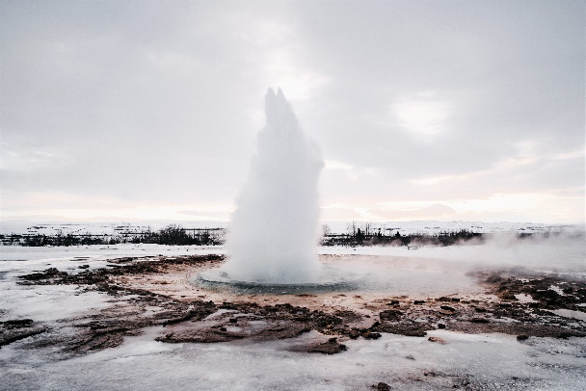

*Sunday September 11, 2022*

**Prelude** Dr. Christina Romero

\***Gathering Song**  *Joy to the World (Unspeakable Joy)*

*You Are My King (Amazing Love)*

**\*Call to Worship**

*One: Hear the Word of the Lord: You are dust and to dust you will return.*

**Many: We are the Lord’s. We have been beautifully and wonderfully created.**

*One: God has breathed the Spirit into you. You are precious to God.*

**Many: The Spirit lives within us all. We will treasure this presence.**

*One: We are alive because God is with us. God’s very presence lives in us.*

**All: We will seek this presence that lives in us. We will search for this presence that lives in others. We will cherish all life as given by God.**

**\*Invocation & Lord’s Prayer (use “sins)** Julianne Thomas

**\*Hymn** *All Hail the Power of Jesus Name #43*

**Scripture Reading** 1 Kings 8:22-30 Julianne Thomas

*One: Hear what God is saying to the people.*

**All: Thanks be to God!**

**Worship Prayer** *Cares Chorus* Tom Bartley

**\*Hymn** *There’s Something About That Name #83*

**Youth and Children’s Message** Julianne Thomas

**Scripture Reflection** Genesis 2:4b-25 Tom Bartley

**\*Hymn of Response** *My Faith Looks Up to Thee #539*

**Response to God**

**Offertory** Dr. Christina Romero **\*Doxology**

**\*Prayer** Julianne Thomas

**Benediction**  Tom Bartley

**Postlude**  Dr. Christina Romero

**CONTACT INFORMATION**

New Bethel Baptist Church **Website:** www.newbethelbapt.org

8936 Southeastern Avenue **E-mail:** newbethelbapt@att.net Indianapolis, IN 46239 **Wi-fi password:** NBBC8624381

317-862-4381

**Worship Music Copyright and Live-Streaming Permissions**

All selections ©1997 Word/Integrity Used by Permission.

CCLI License #1631733

Live-Streaming: CCS, WorshipCast, License #10868