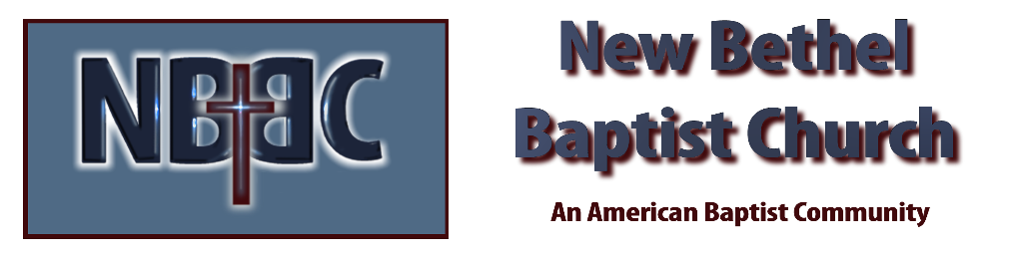
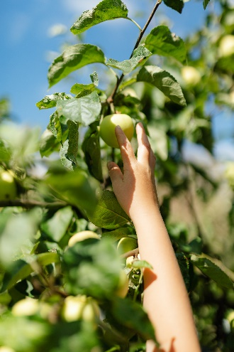
Sunday September 18, 2022

Prelude Dr. Christina Romero

*Gathering Song Trading My Sorrows
You are My All in All

*Call to Worship
Many: We enter this house searching for the Lord.
One: But God is already searching for us.
Many: We enter this building to speak to our God.
One: But God is already speaking to us.
Many: Today, this is the place where the Lord can find us and speak to our hearts.
All: It is the Lord who call us together and the Lord who will lead us home.

*Invocation & Lord’s Prayer (use “sins) Julianne Thomas

*Hymn Heaven Came Down #510

Scripture Reading 1 Kings 9:1-9 Julianne Thomas
One: Hear what God is saying to the people.
All: Thanks be to God!

Worship Prayer Cares Chorus Tom Bartley

*Hymn Great is the Lord #305

Mission Moment Kevin Stone

Scripture Reflection Genesis 3:1-19 Tom Bartley

*Hymn of Response Now I Belong to Jesus #501

Response to God
Offertory Dr. Christina Romero *Doxology
*Prayer Julianne Thomas

Benediction Tom Bartley
Postlude Dr. Christina Romero

CONTACT INFORMATION
New Bethel Baptist Church Website: www.newbethelbapt.org
8936 Southeastern Avenue E-mail: newbethelbapt@att.net Indianapolis, IN 46239 Wi-fi password: NBBC8624381
317-862-4381
Worship Music Copyright and Live-Streaming Permissions
All selections ©1997 Word/Integrity Used by Permission.
CCLI License #1631733

Live-Streaming: CCS, WorshipCast, License #10868

