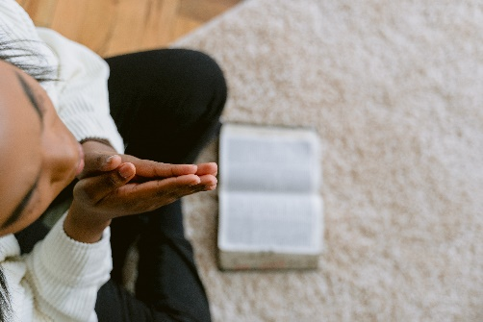

*Sunday September 4, 2022*

**Prelude** Dr. Christina Romero

\***Gathering Song**  *O Worship the King #104 (v. 1, 2, 5)*

**\*Call to Worship**

**Many: We have gathered to hear the Word of the Lord.**

*One: Listen! Listen carefully for God is speaking.*

**Many: We are present to listen for the Word of God.**

*One: God speaks! And the Word is a silent whisper and a great shout!*

**Many: God speaks, and we are reborn!**

**All: Speak the Words of Love we need to hear, O Lord. Communicate your desires to our hearts, our minds, and our bodies.**

**\*Invocation & Lord’s Prayer (use “sins)** Julianne Thomas

**\*Worship Songs** *Jesus Messiah*

*Build Your Kingdom Here*

**Scripture Reading** 1 Kings 6:1-13 Julianne Thomas

**Worship Prayer** *Cares Chorus* Tom Bartley

**\*Hymn** *We Will Glorify #105*

**Youth and Children’s Message** Julianne Thomas

**Response to God**

**Offertory** Dr. Christina Romero **\*Doxology**

**\*Prayer** Julianne Thomas

**Lectio Divina** Tom Bartley

**\*Invitation Hymn** *How Great Thou Art #147*

**Communion**

**Benediction**  Tom Bartley

*Blest Be the Ties That Bind*

**Postlude**  Dr. Christina Romero

**CONTACT INFORMATION**

New Bethel Baptist Church **Website:** www.newbethelbapt.org

8936 Southeastern Avenue **E-mail:** newbethelbapt@att.net Indianapolis, IN 46239 **Wi-fi password:** NBBC8624381

317-862-4381

**Worship Music Copyright and Live-Streaming Permissions**

All selections ©1997 Word/Integrity Used by Permission.

CCLI License #1631733

Live-Streaming: CCS, WorshipCast, License #10868