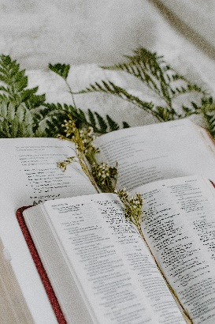

*Sunday October 16, 2022*

**Prelude** Dr. Christina Romero

\***Gathering Song** *Open My Eyes, That I May See #563*

**\*Call to Worship**

*One: Come and hear the Word of the Lord.*

**Many: We gather to hear the good news about God.**

*One: The Lord speaks and the Word is of hope and love.*

**Many: We receive the Word with joy in our hearts.**

*One: Come and hear the Word of the Lord.*

**All: God speaks and the Word brings us new life!**

**\*Invocation & Lord’s Prayer (use “sins)** Rev. Tom Bridges

**\*Hymn** *Be Thou My Vision #562*

**Scripture Reading** 1 Kings 17:1-16 Julianne Thomas

*One: Hear what God is saying to the people.*

**All: Thanks be to God!**

**Worship Prayer** *Cares Chorus* Julianne Thomas

**\*Hymn** *All the Way My Savior Leads Me #680*

**Children & Youth Message** Julianne Thomas

**Scripture Reflection** *Life Spiritually Discerned* Rev. Tom Bridges

John 6:51-58

**\*Hymn of Response** *He Leadeth Me #690*

**Response to God**

**Offertory** Dr. Christina Romero **\*Doxology**

**\*Prayer** Julianne Thomas

**Benediction**  Rev. Tom Bridges

**Postlude**  Dr. Christina Romero

**CONTACT INFORMATION**

New Bethel Baptist Church **Website:** www.newbethelbapt.org

8936 Southeastern Avenue **E-mail:** newbethelbapt@att.net Indianapolis, IN 46239 **Wi-fi password:** NBBC8624381

317-862-4381

**Worship Music Copyright and Live-Streaming Permissions**

All selections ©1997 Word/Integrity Used by Permission.

CCLI License #1631733

Live-Streaming: CCS, WorshipCast, License #10868