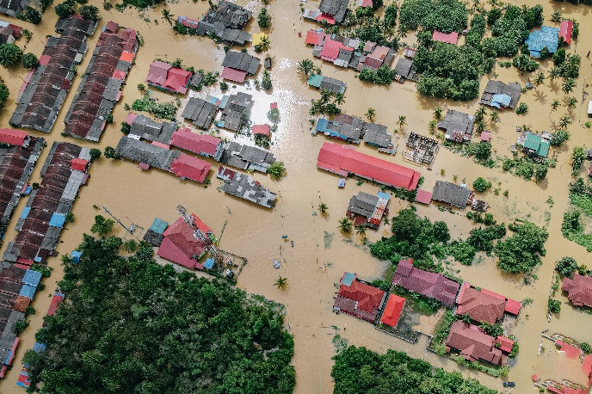

*World Communion Sunday October 2, 2022*

**Prelude** Dr. Christina Romero

\***Gathering Song** *O Worship the King #104*

**\*Call to Worship**

*One: We are created in Gods own image.*

**Many: God calls us to love one another.**

*One: When we love, we resemble our God.*

**Many: Because God is love.**

*One: Come, let us worship God and seek a path to love ourselves and to love others.*

**All: Anyone who loves is born of God and knows God, because God is love.**

**\*Invocation & Lord’s Prayer (use “sins)** Julianne Thomas

**\*Hymn** *Fairest Lord Jesus #87*

**Scripture Reading** 1 Kings 11:1-13 Julianne Thomas

*One: Hear what God is saying to the people.*

**All: Thanks be to God!**

**Worship Prayer** *Cares Chorus* Tom Bartley

**\*Hymn** *Thou Art Worthy #100*

**Children & Youth Message**  Tom Bartley

**Scripture Reflection** Genesis 6:9 -7:5 Tom Bartley

**\*Hymn of Response** *As the Deer #548*

**Response to God**

**Offertory** Dr. Christina Romero **\*Doxology**

**\*Prayer** Julianne Thomas

**Communion Hymn** *Come Share the Lord #462*

**Communion**

**Benediction**  *Blest Be the Tie That Binds* Tom Bartley

**Postlude**  Dr. Christina Romero

**CONTACT INFORMATION**

New Bethel Baptist Church **Website:** www.newbethelbapt.org

8936 Southeastern Avenue **E-mail:** newbethelbapt@att.net Indianapolis, IN 46239 **Wi-fi password:** NBBC8624381

317-862-4381

**Worship Music Copyright and Live-Streaming Permissions**

All selections ©1997 Word/Integrity Used by Permission.

CCLI License #1631733

Live-Streaming: CCS, WorshipCast, License #10868