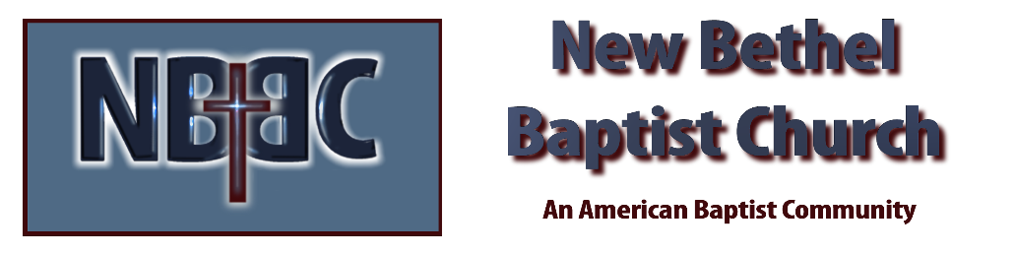

Sunday October 23, 2022

Prelude Dr. Christina Romero

*Gathering Song Build Your Kingdom Here
10,00 Reasons

*Call to Worship
One: We are God’s beloved creation.
Many: God has blessed us with the gift of life and love.
One: God’s love has made us a new creation.
Many: We have been saved from death and called for a purpose.
One: We are called to share God’s gifts.
All: We will carry the blessings of our God into the world.

*Invocation & Lord’s Prayer (use “sins) Julianne Thomas

*Hymn Take My Life and Let It Be Consecrated #597

Scripture Reading 1 Kings 19:9b-18 Julianne Thomas
One: Hear what God is saying to the people.
All: Thanks be to God!

Worship Prayer Cares Chorus Re. Tom Bartley

*Hymn Freely, Freely #436

Children & Youth Message Julianne Thomas

Scripture Reflection Luke 19:11-27 Rev. Tom Bartley

*Hymn of Response Here I Am Lord #589

Response to God
Offertory Dr. Christina Romero *Doxology
*Prayer Julianne Thomas

Benediction Rev. Tom Bartley
Postlude Dr. Christina Romero

CONTACT INFORMATION
New Bethel Baptist Church Website: www.newbethelbapt.org
8936 Southeastern Avenue E-mail: newbethelbapt@att.net Indianapolis, IN 46239 Wi-fi password: NBBC8624381
317-862-4381
Worship Music Copyright and Live-Streaming Permissions
All selections ©1997 Word/Integrity Used by Permission.
CCLI License #1631733

Live-Streaming: CCS, WorshipCast, License #10868

