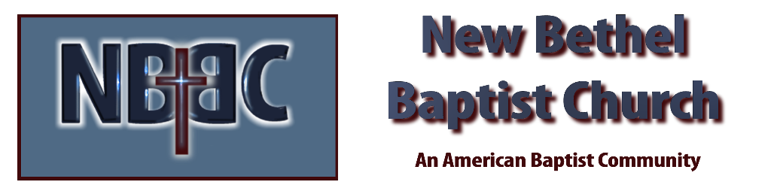
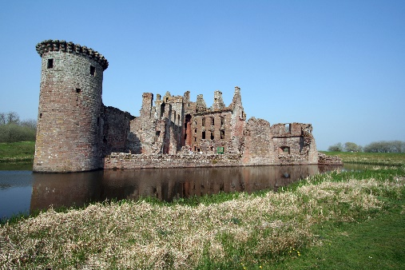
Sunday October 9, 2022

Prelude Dr. Christina Romero

*Gathering Song Jesus Messiah
How Great is Our God

*Call to Worship
One: Come, all you who labor under a heavy burden.
Many: Come and find rest in the Lord.
One: Come and find rest for your body and for your spirit.
Many: For the Lord is present in this place.
One: The Spirit of the Lord is with us and God offers us peace.
All: Today we gather seeking the peace that comes from being present with the Lord.

*Invocation & Lord’s Prayer (use “sins) Julianne Thomas

*Hymn May Jesus Christ Be Praised #215

Scripture Reading 1 Kings 12:1-17 Julianne Thomas
One: Hear what God is saying to the people.
All: Thanks be to God!

Worship Prayer Cares Chorus Tom Bartley

*Hymn His Name is Wonderful #118

Children & Youth Message Julianne Thomas

Scripture Reflection Genesis 14:8-20 Tom Bartley

*Hymn of Response I Surrender All #596

Response to God
Offertory Dr. Christina Romero *Doxology
*Prayer Julianne Thomas

Benediction Tom Bartley
Postlude Dr. Christina Romero

CONTACT INFORMATION
New Bethel Baptist Church Website: www.newbethelbapt.org
8936 Southeastern Avenue E-mail: newbethelbapt@att.net Indianapolis, IN 46239 Wi-fi password: NBBC8624381
317-862-4381
Worship Music Copyright and Live-Streaming Permissions
All selections ©1997 Word/Integrity Used by Permission.
CCLI License #1631733

Live-Streaming: CCS, WorshipCast, License #10868

