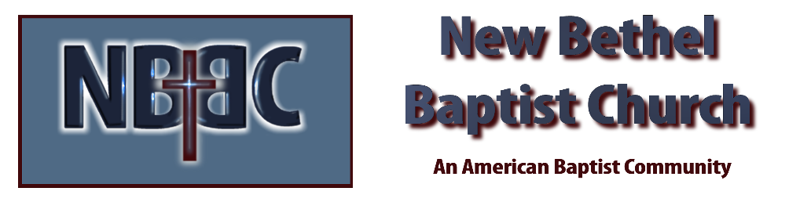

Sunday November 13, 2022

Prelude Dr. Christina Romero

*Gathering Song Mighty to Save
Draw Me Close

*Call to Worship Julianne Thomas
One: Lord, draw us into your loving embrace.
Many: Thank you for your faithfulness to us.
One: When the storms of life blow, we will not be afraid.
Many: For we know that our God is with us.
One: Therefore we will not be afraid.
All: For God is our hope, our strength, and shield.

*Invocation & Lord’s Prayer (use “sins) Julianne Thomas

*Hymn When We all Get to Heaven #772

Scripture Reading 2 Kings 2:19-25 Julianne Thomas
One: Hear what God is saying to the people.
All: Thanks be to God!

Worship Prayer Cares Chorus Rev. Tom Bartley

*Hymn There’s Something About That Name #83

Children & Youth Message Julianne Thomas

Scripture Reflection Matthew 9:9-13 Rev. Tom Bartley

*Hymn of Response My Jesus I Love Thee #79

Response to God

Offertory Dr. Christina Romero *Doxology
*Prayer Julianne Thomas

Benediction Rev. Tom Bartley

Postlude Dr. Christina Romero

CONTACT INFORMATION
New Bethel Baptist Church Website: www.newbethelbapt.org
8936 Southeastern Avenue E-mail: newbethelbapt@att.net Indianapolis, IN 46239 Wi-fi password: NBBC8624381
317-862-4381
Worship Music Copyright and Live-Streaming Permissions
All selections ©1997 Word/Integrity Used by Permission.
CCLI License #1631733

Live-Streaming: CCS, WorshipCast, License #10868

