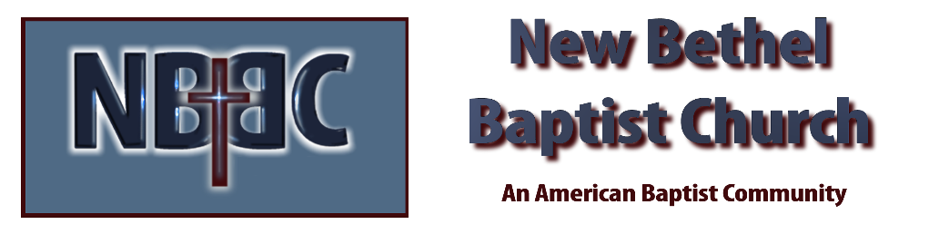
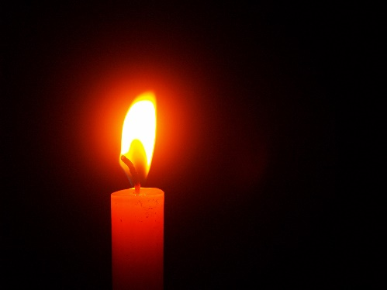
First Sunday in Advent, November 227, 2022

Prelude Dr. Christina Romero

*Gathering Song O Come O Come Emmanuel

*Call to Worship Julianne Thomas
Many: We come seeking hope .
One: Come, let us go to God. Our Divine Parent will teach us how to hope.
Many: We come seeking light.
One: The hope we find in God is like a candle flame in the dark.
Many: When we seek God’s presence and teaching the flame becomes brighter.
All: Come, let us walk in the light of God.

Advent Moment Julianne Thomas

*Hymn Come Thou Long Expected Jesus #244

Scripture Reading Isaiah 7:13-17 Julianne Thomas
One: Hear what God is saying to the people.
All: Thanks be to God!

Worship Prayer Cares Chorus Rev. Tom Bartley

*Hymn Emmanual #243

Children & Youth Message Julianne Thomas

Special Music As Water to the Thirsty Dr. Christina Romero & Kevin Stone

Scripture Reflection Mark 1:1-8 Rev. Tom Bartley

*Hymn of Response O Little Town of Bethlehem #250

Response to God

Offertory Dr. Christina Romero *Doxology
*Prayer Julianne Thomas

Benediction Rev. Tom Bartley

Postlude Dr. Christina Romero

Lectionary Readings for Decmeber
Thursday December 1st: Isaiah 4:2-6; Acts 1:12-17, 21-26; Psalm 72:1-7, 18-19
Friday December 2nd: Isaiah 30:19-26; Acts 13:16-25: Psalm 72:1-7, 18-19
Saturday December 3rd: Isaiah 40:1-11; John 1:19-28; Psalm 72:1-7, 18-19

CONTACT INFORMATION
New Bethel Baptist Church Website: www.newbethelbapt.org
8936 Southeastern Avenue E-mail: newbethelbapt@att.net Indianapolis, IN 46239 Wi-fi password: NBBC8624381
317-862-4381
Worship Music Copyright and Live-Streaming Permissions
All selections ©1997 Word/Integrity Used by Permission.
CCLI License #1631733

Live-Streaming: CCS, WorshipCast, License #10868

