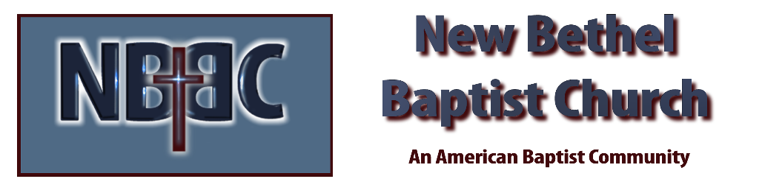

New Year’s Day, Sunday, January 1, 2023

Prelude Douglas Carter

*Gathering Song Here I Am to Worship
Build Your Kingdom Here

*Call to Worship Julianne Thomas
One: A new year is before us, full of new opportunities.
Many: We have a new chance to follow God’s purpose for us.
One: A new year is before us, offering us new paths in ministry.
Many: We will follow God’s guidance, trusting in the Creator’s path for us.
One: A new year is before us, offering us a new beginning as a community called by God.
All: We have been called by God to love and to serve. We will journey with each other and the Holy Spirit as we respond to God’s call.

Invocation Julianne Thomas

Hymn Come, Christians Join to Sing #225

Scripture Reading Daniel 1:1-17 Julianne Thomas
One: Hear what God is saying to the people.
All: Thanks be to God!

Worship Prayer Cares Chorus Rev. Tom Bartley

*Hymn Angels From the Realm of Glory #259

Children’s Message Julianne Thomas

Scripture Reflection Matthew 2:13-23 Rev. Tom Bartley

*Hymn of Response Wonderful Words of Life #406

Offertory Douglas Carter *Doxology
*Prayer Julianne Thomas

Special Music Trust Rev. Tom Bartley

Communion

Benediction Blest Be the Tie That Binds Rev. Tom Bartley

Postlude Douglas Carter

CONTACT INFORMATION
New Bethel Baptist Church Website: www.newbethelbapt.org
8936 Southeastern Avenue E-mail: newbethelbapt@att.net Indianapolis, IN 46239 Wi-fi password: NBBC8624381
317-862-4381
Worship Music Copyright and Live-Streaming Permissions
All selections ©1997 Word/Integrity Used by Permission.
CCLI License #1631733

Live-Streaming: CCS, WorshipCast, License #10868

