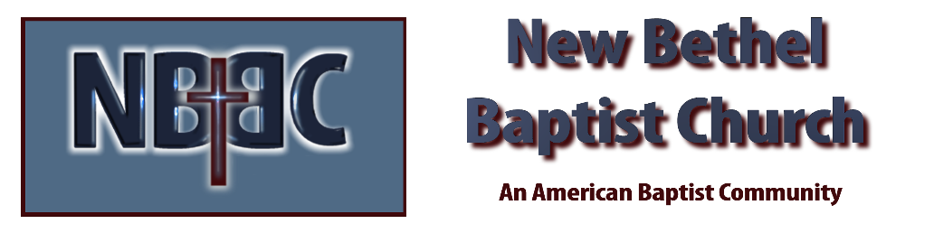
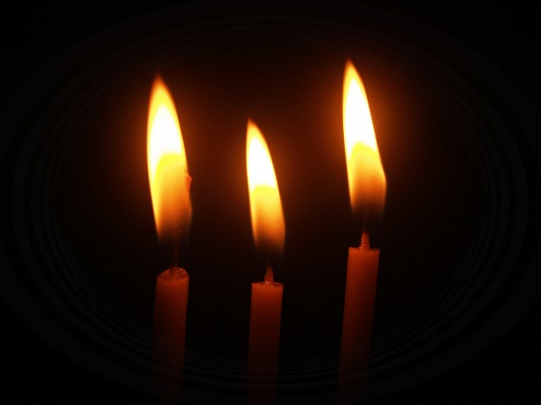
Third Sunday in Advent, December 11, 2022

Prelude Jaci Greig

*Gathering Song Joy to the World (Unspeakable Joy)

*Call to Worship Julianne Thomas
All: Be still and know that I am God!
Be still and know that I am.
Be still and know.
Be still.
Be.

Advent Moment Johnny Hopkins

*Hymn Angels from the Realm of Glory #259

Scripture Reading Isaiah 11:1-9 Julianne Thomas
One: Hear what God is saying to the people.
All: Thanks be to God!

Worship Prayer Cares Chorus Rev. Tom Bartley

*Hymn Away in a Manger #261

Children & Youth Message Julianne Thomas

Scripture Reflection Luke 2:8-20 Rev. Tom Bartley

*Hymn of Response Hark the Herald Angels Sing #277

Offertory Jaci Greig *Doxology
*Prayer Julianne Thomas
Benediction

Postlude Jaci Greig

CONTACT INFORMATION
New Bethel Baptist Church Website: www.newbethelbapt.org
8936 Southeastern Avenue E-mail: newbethelbapt@att.net Indianapolis, IN 46239 Wi-fi password: NBBC8624381
317-862-4381
Worship Music Copyright and Live-Streaming Permissions
All selections ©1997 Word/Integrity Used by Permission.
CCLI License #1631733

Live-Streaming: CCS, WorshipCast, License #10868

