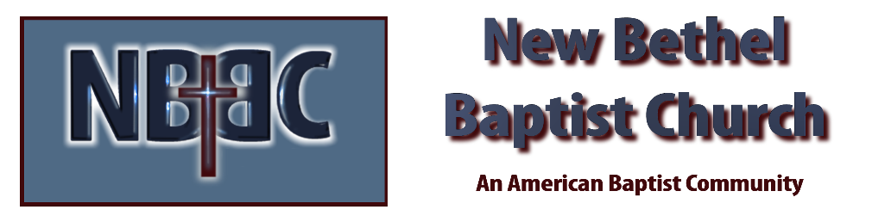
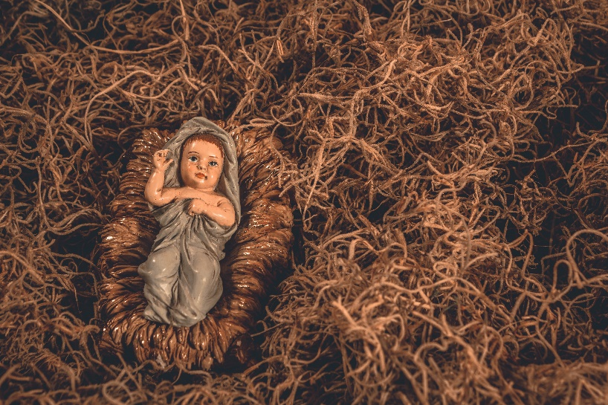
Christmas Morning, Sunday, December 25, 2022

Prelude Jaci Greig

*Gathering Song O Come O Come Emmanuel #245
Angels From the Realm of Glory #259

*Call to Worship Julianne Thomas
One: A journey for a census. A search for a place to rest and give birth.
Many: A manger and a star.
One: The heralding of angels, bringing a message of great joy.
Many: The care and love of strangers from near and far.
One: That night so long ago, when Christ the Messiah was born.
All: Hallelujah! Joy to the world! Our Savior, Jesus Christ is born!

Invocation Julianne Thomas

Hymn The First Noel #265

Scripture Reading John 1:1-14 Julianne Thomas
One: Hear what God is saying to the people.
All: Thanks be to God!

Worship Prayer Cares Chorus Julianne Thomas

*Hymn Joy to the World #270

Children’s Message Jim Winton

Special Music Joseph’s Song Tom Bartley

Scripture Reflection Luke 2:1-7 Tom Bartley

*Hymn of Response Go Tell It on the Mountain #258

Offertory Jaci Greig *Doxology
*Prayer Julianne Thomas

Benediction Tom Bartley

Postlude Jaci Grieg

CONTACT INFORMATION
New Bethel Baptist Church Website: www.newbethelbapt.org
8936 Southeastern Avenue E-mail: newbethelbapt@att.net Indianapolis, IN 46239 Wi-fi password: NBBC8624381
317-862-4381
Worship Music Copyright and Live-Streaming Permissions
All selections ©1997 Word/Integrity Used by Permission.
CCLI License #1631733

Live-Streaming: CCS, WorshipCast, License #10868

