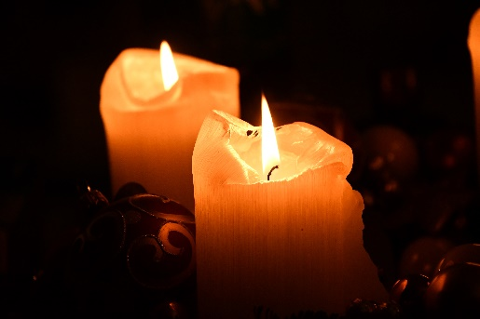

*Second Sunday in Advent, December 4, 2022*

**Prelude** Dr. Christina Romero

\***Gathering Song** *O Come O Come Emmanuel*

**\*Call to Worship** *(Adapted from Psalm 146:5-10)* Julianne Thomas

*One: Joyful are those who have the God of Israel as their helper, whose hope is in the Lord their God.*

**Many: God made heaven and earth, the sea, and everything in them. God keeps every promise forever.**

*One: God gives justice to the oppressed and food to the hungry. The Lord frees the prisoners.*

**Many: The Lord opens the eyes of the blind. The Lord lifts up those who are weighed down.**

*One: The Lord protects the foreigners among us, cares for the orphans and widows, and frustrates the plans of the wicked.*

**All: God will reign forever. Praise to the Lord!**

**Advent Moment**  Barb Fengya & Sherry Hiner

**\*Hymn** *O Come All Ye Faithful #249*

**Scripture Reading** Isaiah 43:1-5 Julianne Thomas

*One: Hear what God is saying to the people.*

**All: Thanks be to God!**

**Worship Prayer** *Cares Chorus* Rev. Tom Bartley

**\*Hymn** *It Came Upon The Midnight Clear #251*

**Children & Youth Message** Julianne Thomas

**Special Music** *Babe in the Straw* Rev. Tom Bartley

**Scripture Reflection** *Matthew 11:28-30* Rev. Tom Bartley

**\*Hymn of Response** *Go Tell It On The Mountain #258*

**Offertory** Dr. Christina Romero **\*Doxology**

**\*Prayer** Julianne Thomas

**Communion**

**Benediction** *Blest Be the Tie That Binds*

**Postlude**  Dr. Christina Romero

**CONTACT INFORMATION**

New Bethel Baptist Church **Website:** www.newbethelbapt.org

8936 Southeastern Avenue **E-mail:** newbethelbapt@att.net Indianapolis, IN 46239 **Wi-fi password:** NBBC8624381

317-862-4381

**Worship Music Copyright and Live-Streaming Permissions**

All selections ©1997 Word/Integrity Used by Permission.

CCLI License #1631733

Live-Streaming: CCS, WorshipCast, License #10868