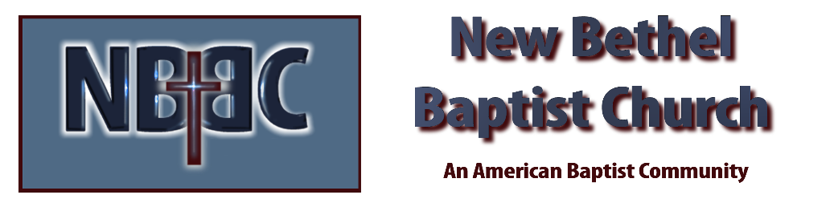
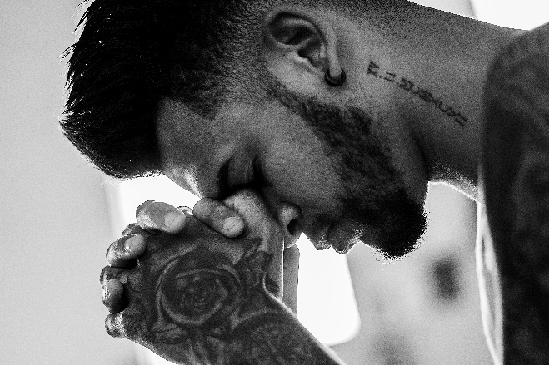
Sunday, January 15, 2023

Prelude Dr. Christina Romero

*Gathering Song The Heart of Worship
You Are My King (Amazing Love)
*Call to Worship Julianne Thomas
Many: God you are our refuge.
One: You are the shore in sight, you are hands that reach out, you are the ground on which to rest.
Many: God you are our strength.
One: You are the life we long for, you are the refusal to give up, you are the keys of home we carry with us.
Many: God you are our help in time of trouble.
One: We call on you from the ruins and the rubble, we call on you from the wildness and the deep,
All: We call on you to meet us in this place!

Invocation Julianne Thomas

Hymn I Need Thee Every Hour #638

Scripture Reading Daniel 2:14-28 Julianne Thomas
One: Hear what God is saying to the people.
All: Thanks be to God!

Worship Prayer Cares Chorus Rev. Tom Bartley

*Hymn Sweet Hour of Prayer #640

Children’s Message Julianne Thomas

Scripture Reflection Matthew 26:36-46 Rev. Tom Bartley

*Hymn of Response In the Garden #635

Offertory Dr. Christina Romero *Doxology
*Prayer Julianne Thomas

Benediction Rev. Tom Bartley

Postlude Dr. Christina Romero

CONTACT INFORMATION
New Bethel Baptist Church Website: www.newbethelbapt.org
8936 Southeastern Avenue E-mail: newbethelbapt@att.net Indianapolis, IN 46239 Wi-fi password: NBBC8624381
317-862-4381
Worship Music Copyright and Live-Streaming Permissions
All selections ©1997 Word/Integrity Used by Permission.
CCLI License #1631733

Live-Streaming: CCS, WorshipCast, License #10868

