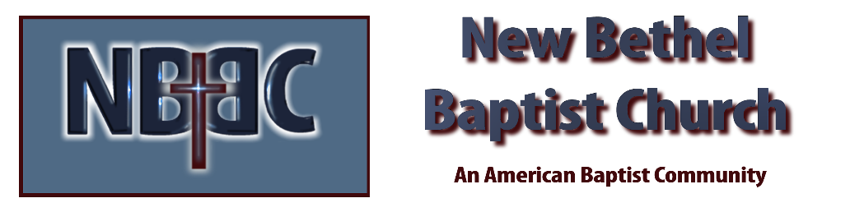
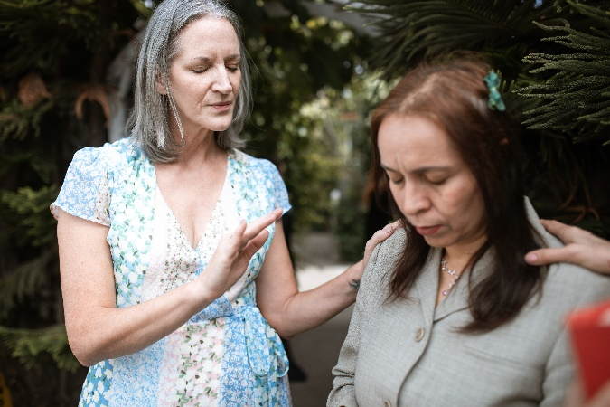
Sunday, January 22, 2023

Prelude Dr. Christina Romero

Centering and Call to Worship Julianne Thomas

Invocation & Lord’s Prayer (using “sins”) Julianne Thomas

*Hymn His Eye is On the Sparrow #624

Scripture Reading Daniel 2:29-49 Julianne Thomas
One: Hear what God is saying to the people.
All: Thanks be to God!

Worship Prayer Cares Chorus Rev. Tom Bartley

*Hymn Open Our Eyes, Lord #633

Children’s Message Rev. Tom Bartley

Scripture Reflection James 5:13-20 Rev. Tom Bartley

*Hymn of Response What a Friend We Have in Jesus #635

Offertory Dr. Christina Romero *Doxology
*Prayer Julianne Thomas

Benediction Rev. Tom Bartley

Postlude Dr. Christina Romero

CONTACT INFORMATION
New Bethel Baptist Church Website: www.newbethelbapt.org
8936 Southeastern Avenue E-mail: newbethelbapt@att.net Indianapolis, IN 46239 Wi-fi password: NBBC8624381
317-862-4381
Worship Music Copyright and Live-Streaming Permissions
All selections ©1997 Word/Integrity Used by Permission.
CCLI License #1631733

Live-Streaming: CCS, WorshipCast, License #10868

