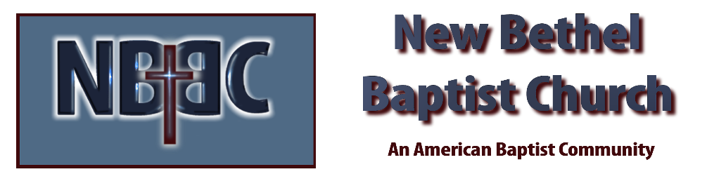

Sunday, January 29, 2023

Prelude Dr. Christina Romero

*Gathering Songs Build Your Kingdom Here
More Love, More Power

Call to Worship Julianne Thomas
One: Come Lord Jesus, dwell within us.
Many: Come and guide us in your ways of Love.
One: Come Lord Jesus, dwell within us.
Many: Come and teach us how to pray and listen to God.
One: Come Lord Jesus, dwell within us.
All: Come, we are seeking you. Come, we are open to your teaching.

Invocation & Lord’s Prayer (using “sins”) Julianne Thomas

Hymn Just a Closer Walk With Thee #564

Scripture Reading Daniel 3:1-18 Julianne Thomas
One: Hear what God is saying to the people.
All: Thanks be to God!

Worship Prayer Cares Chorus Rev. Tom Bartley

*Hymn Blessed Assurance #572

Children’s Message Julianne Thomas

Scripture Reflection Matthew 6:5-15 Rev. Tom Bartley

*Hymn of Response Have Thine Own Way, Lord #635

Offertory Dr. Christina Romero *Doxology
*Prayer Julianne Thomas

Benediction Rev. Tom Bartley

Postlude Dr. Christina Romero

CONTACT INFORMATION
New Bethel Baptist Church Website: www.newbethelbapt.org
8936 Southeastern Avenue E-mail: newbethelbapt@att.net Indianapolis, IN 46239 Wi-fi password: NBBC8624381
317-862-4381
Worship Music Copyright and Live-Streaming Permissions
All selections ©1997 Word/Integrity Used by Permission.
CCLI License #1631733

Live-Streaming: CCS, WorshipCast, License #10868

