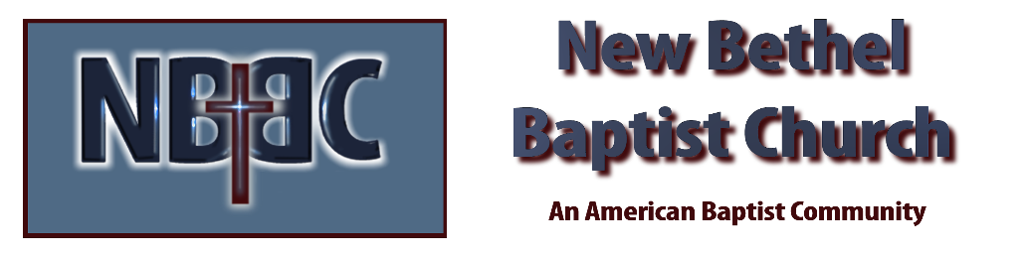
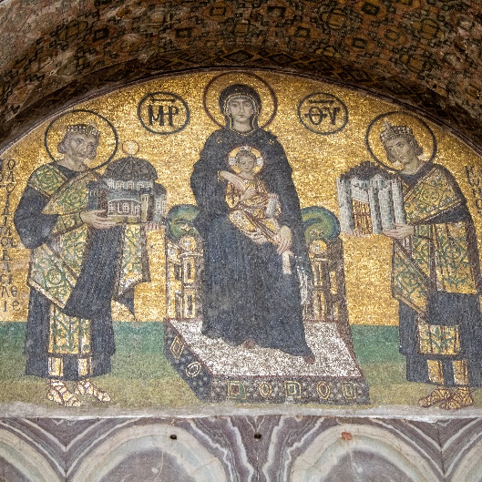
Sunday, January 8, 2023

Prelude Dr. Christina Romero

*Gathering Song Come Thou Fount Come Thou King
Breathe

*Call to Worship Julianne Thomas
One: The three Magi sought Jesus as a baby, traveling far and trusting in a star.
Many: They did not know him or who he would become yet honored him with praise and gifts.
One: Just like the Magi, we are invited to search for Jesus, to honor him with our praise.
Many: We come seeking Jesus, the infant who will become Christ our Savior.
One: How shall we honor Christ our Savior?
All: We shall walk in his path, loving our neighbor and serving those in need.

Invocation Julianne Thomas

Hymn What Child is This #281

Scripture Reading Daniel 1:18-2:13 Julianne Thomas
One: Hear what God is saying to the people.
All: Thanks be to God!

Worship Prayer Cares Chorus Rev. Tom Bartley

*Hymn We Three Kings #288

Children’s Message Julianne Thomas

Scripture Reflection Matthew 2:1-12 Rev. Tom Bartley

*Hymn of Response Shine Jesus Shine #431

Offertory Dr. Christina Romero *Doxology
*Prayer Julianne Thomas

Benediction Rev. Tom Bartley

Postlude Dr. Christina Romero

*Remember to visit Fellowship Hall for your Christmas cards.

CONTACT INFORMATION
New Bethel Baptist Church Website: www.newbethelbapt.org
8936 Southeastern Avenue E-mail: newbethelbapt@att.net Indianapolis, IN 46239 Wi-fi password: NBBC8624381
317-862-4381
Worship Music Copyright and Live-Streaming Permissions
All selections ©1997 Word/Integrity Used by Permission.
CCLI License #1631733

Live-Streaming: CCS, WorshipCast, License #10868

