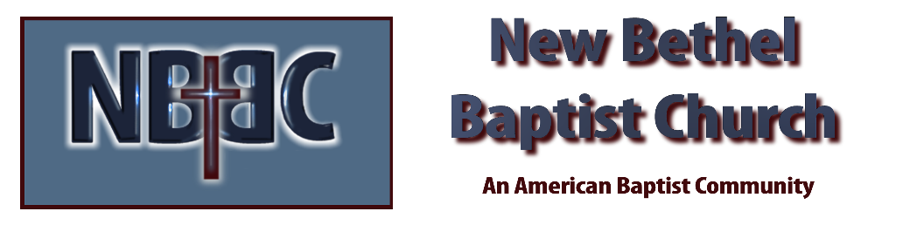

Sunday, February 19, 2023

Prelude Dr. Christina Romero

*Gathering Songs It is Well With My Soul #705

*Call to Worship Julianne Thomas
Many: We have been filled with anger and refused to forgive others.
One: By faith we can be transformed.
Many: We have struggled to see the needs of our neighbors and act to meet them.
One: By faith we will be transformed.
Many: We come seeking the transforming power of God’s love and grace.
All: By our faith we are transformed. Thanks be to God!

*Invocation & Lord’s Prayer (using “sins”) Julianne Thomas

Hymn My Faith Looks Up to Thee #539

Scripture Reading Daniel 4:19-27 Julianne Thomas
One: Hear what God is saying to the people.
All: Thanks be to God!

Worship Prayer Cares Chorus Rev. Tom Bartley

*Hymn Have Faith in God #536

Children’s Message Julianne Thomas

Scripture Reflection Hebrews 11:1-12 Rev. Tom Bartley

*Hymn of Response Faith is the Victory #727

Offertory Dr. Christina Romero *Doxology
*Prayer Julianne Thomas

Benediction Rev. Tom Bartley

Postlude Dr. Christina Romero

CONTACT INFORMATION
New Bethel Baptist Church Website: www.newbethelbapt.org
8936 Southeastern Avenue E-mail: newbethelbapt@att.net Indianapolis, IN 46239 Wi-fi password: NBBC8624381
317-862-4381
Worship Music Copyright and Live-Streaming Permissions
All selections ©1997 Word/Integrity Used by Permission.
CCLI License #1631733

Live-Streaming: CCS, WorshipCast, License #10868

