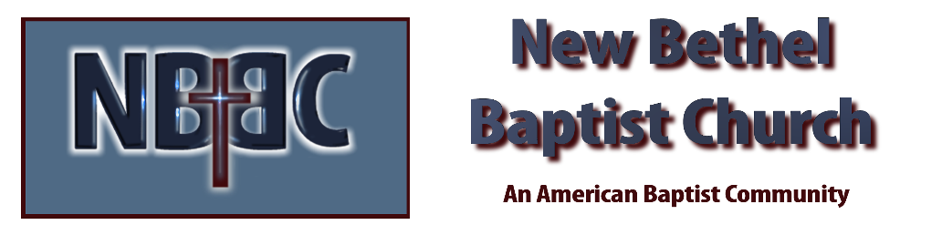
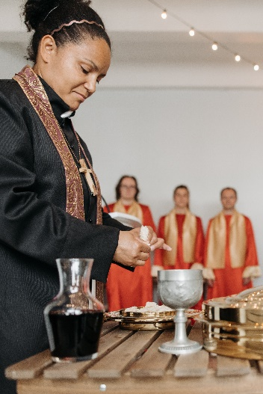
Communion Sunday, February 5, 2023

Prelude Dr. Christina Romero

*Gathering Songs Blessed Be Your Name
Mighty to Save

*Call to Worship Julianne Thomas
One: Lord God, with endless mercy you receive the prayers of all who call upon you.
Many: By your Spirit show us the things we ought to do.
One: Creator God, give us the grace and power to do them.
Many: From you alone comes our hope and strength.
One: Heavenly Parent, hear your children call to you.
All: Creator, Christ, Spirit one, help your children to hear you.

*Invocation & Lord’s Prayer (using “sins”) Julianne Thomas

Hymn We Have Come Into His House #224

Scripture Reading Daniel 3:19-30 Julianne Thomas
One: Hear what God is saying to the people.
All: Thanks be to God!

Worship Prayer Cares Chorus Rev. Tom Bartley

*Hymn O How He Loves You and Me #349

Children’s Message Julianne Thomas

Scripture Reflection Romans 6:1-14 Rev. Tom Bartley

*Hymn of Response Softly and Tenderly #479

Offertory Dr. Christina Romero *Doxology
*Prayer Julianne Thomas

Communion Hymn Come Share the Lord #462

Communion Rev. Tom Bartley

Benediction Blest Be the Tie That Binds

Postlude Dr. Christina Romero

CONTACT INFORMATION
New Bethel Baptist Church Website: www.newbethelbapt.org
8936 Southeastern Avenue E-mail: newbethelbapt@att.net Indianapolis, IN 46239 Wi-fi password: NBBC8624381
317-862-4381
Worship Music Copyright and Live-Streaming Permissions
All selections ©1997 Word/Integrity Used by Permission.
CCLI License #1631733

Live-Streaming: CCS, WorshipCast, License #10868

