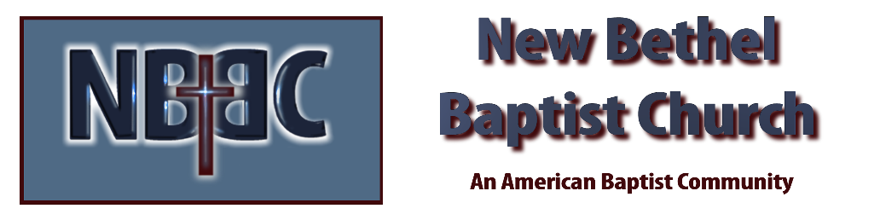

Sunday, March 12, 2023

Prelude Dr. Christina Romero

*Gathering Songs Living Hope
10,000 Reasons

Lenten Moment & Extinguishing the Light Julianne Thomas

Unison Lenten Invocation
Draw us together in your love, O God. May our restless hearts not resist you but continue to search until they find their rest in you. We pray in Jesus’ name. Amen.

*Hymn I Love to Tell the Story #444

Scripture Reading Daniel 5:13-30 Julianne Thomas
One: Hear what God is saying to the people.
All: Thanks be to God!

Worship Prayer Cares Chorus Rev. Tom Bartley

*Hymn People Need the Lord #445

Children’s Message Julianne Thomas

Scripture Reflection Mark 1:1, Matthew 28:18-20 Rev. Tom Bartley

*Hymn of Response Wonderful Words of Life #406

Offertory Dr. Christina Romero *Doxology
*Prayer Julianne Thomas

Benediction Rev. Tom Bartley

Postlude Dr. Christina Romero

CONTACT INFORMATION
New Bethel Baptist Church Website: www.newbethelbapt.org
8936 Southeastern Avenue E-mail: newbethelbapt@att.net Indianapolis, IN 46239 Wi-fi password: NBBC8624381
317-862-4381
Worship Music Copyright and Live-Streaming Permissions
All selections ©1997 Word/Integrity Used by Permission.
CCLI License #1631733

Live-Streaming: CCS, WorshipCast, License #10868

