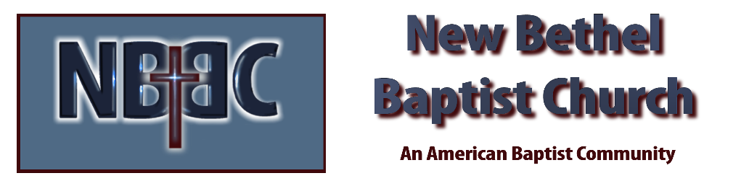

Sunday, March 19, 2023

Prelude Dr. Christina Romero

*Gathering Songs Mighty to Save
Jesus Loves Me

Lenten Moment & Extinguishing the Light Julianne Thomas

Unison Lenten Invocation
Loving God, we thank you that you are with us, and that we may call upon you no matter where we are, or what we are feeling. Keep us mindful of your presence and trusting in your promise—that you are working with us in the moment-by-moment unfolding of our lives. Amen.

*Hymn Blessed Assurance #572

Scripture Reading Daniel 6:1-14 Julianne Thomas
One: Hear what God is saying to the people.
All: Thanks be to God!

Worship Prayer Cares Chorus Rev. Tom Bartley

*Hymn It Is Well With My Soul #705

Children’s Message Julianne Thomas

Scripture Reflection 1 Peter 1:3-9 Rev. Tom Bartley

*Hymn of Response Softly and Tenderly #479

Offertory Dr. Christina Romero *Doxology
*Prayer Julianne Thomas

Benediction Rev. Tom Bartley

Postlude Dr. Christina Romero

CONTACT INFORMATION
New Bethel Baptist Church Website: www.newbethelbapt.org
8936 Southeastern Avenue E-mail: newbethelbapt@att.net Indianapolis, IN 46239 Wi-fi password: NBBC8624381
317-862-4381
Worship Music Copyright and Live-Streaming Permissions
All selections ©1997 Word/Integrity Used by Permission.
CCLI License #1631733

Live-Streaming: CCS, WorshipCast, License #10868

