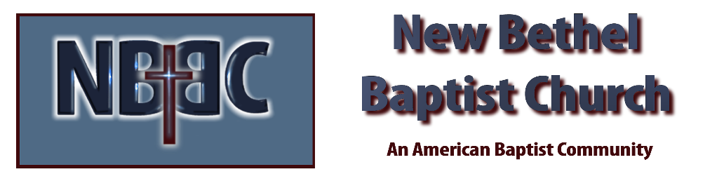

Sunday, March 26, 2023

Prelude Dr. Christina Romero

*Gathering Songs You Are My King (Amazing Love)
Amazing Grace My Chains Are Gone

Lenten Moment & Extinguishing the Light Julianne Thomas

Unison Lenten Invocation
Loving God, we open our hearts to you. We invite you into our inmost being, only to find you already there. Strengthen us in our quiet places and then lead us into the work of justice and peace. Amen.

*Hymn My Jesus I Love Thee #79

Scripture Reading Daniel 6:15-24 Julianne Thomas
One: Hear what God is saying to the people.
All: Thanks be to God!

Worship Prayer Cares Chorus Rev. Tom Bartley

*Hymn Thou Art Worthy #100

Mission Moment Dick Juday

Scripture Reflection 1 Corinthians 13:1-13 Rev. Tom Bartley

*Hymn of Response Here I am Lord #589

Offertory Dr. Christina Romero *Doxology
*Prayer Julianne Thomas

Benediction Rev. Tom Bartley

Postlude Dr. Christina Romero

CONTACT INFORMATION
New Bethel Baptist Church Website: www.newbethelbapt.org
8936 Southeastern Avenue E-mail: newbethelbapt@att.net Indianapolis, IN 46239 Wi-fi password: NBBC8624381
317-862-4381
Worship Music Copyright and Live-Streaming Permissions
All selections ©1997 Word/Integrity Used by Permission.
CCLI License #1631733

Live-Streaming: CCS, WorshipCast, License #10868

