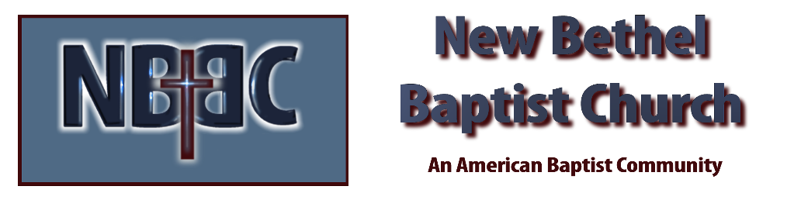

Sunday, April 16, 2023

Prelude Bach Prelude #1 Rev. Judy Fackenthal
Easter Medley

*Gathering Song Undignified
Build Your Kingdom Here

*Call to Worship Julianne Thomas
One: Christ Has Died!
Many: Christ Has Risen!
All: Christ will come again!
One: Today we remember the sacrifice that Jesus has made.
Many: We celebrate the victory his sacrifice has made possible.
All: New life is available to those who accept and believe.

Invocation & Lord’s Prayer Julianne Thomas

*Hymn Holy, Holy, Holy! Lord God Almighty #3

Scripture Reading Daniel 8:1-12 Julianne Thomas
One: Hear what God is saying to the people.
All: Thanks be to God!

Worship Prayer Cares Chorus Rev. Tom Bartley

*Hymn Father I Adore You #191

Children and Youth Message Julianne Thomas

Scripture Reflection Matthew 28:18-20 Rev. Tom Bartley

*Hymn of Response Come Thou Almighty King #8

Offertory Rev. Judy Fackenthal *Doxology
*Prayer Julianne Thomas

Benediction Rev. Tom Bartley

Postlude Rev. Judy Fackenthal

CONTACT INFORMATION
New Bethel Baptist Church Website: www.newbethelbapt.org
8936 Southeastern Avenue E-mail: newbethelbapt@att.net Indianapolis, IN 46239 Wi-fi password: NBBC8624381
317-862-4381
Worship Music Copyright and Live-Streaming Permissions
All selections ©1997 Word/Integrity Used by Permission.
CCLI License #1631733

Live-Streaming: CCS, WorshipCast, License #10868

