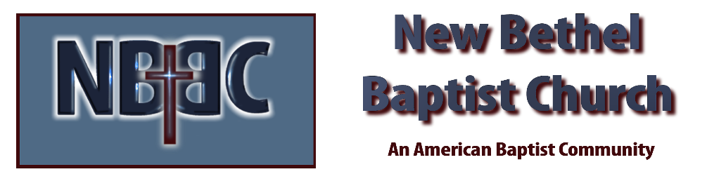

Communion Sunday, April 2, 2023

Prelude Dr. Christina Romero

*Gathering Song We Have Come Into His House #224

Lenten Moment & Extinguishing the Light Julianne Thomas

Unison Lenten Invocation
Loving God, there are so many choices before us every day. Choices offered by our friends, our families, our culture, our own past. Some of them encourage the well-being of the earth, ourselves and our neighbors; others are destructive. Help us to distinguish between them. May we learn from the choices of Jesus and embody compassion, justice, and inclusion in all we say and do. Amen

*Hymn Rejoice the Lord is King #370

Scripture Reading Daniel 7:1-14 Julianne Thomas
One: Hear what God is saying to the people.
All: Thanks be to God!

Worship Prayer Cares Chorus Rev. Tom Bartley

*Hymn God of Grace and God of Glory #435

Children and Youth Message Julianne Thomas

Scripture Reflection Mark 11:1-11 Rev. Tom Bartley

*Hymn of Response We’ve A Story to Tell to the Nations #446

Offertory Dr. Christina Romero *Doxology
*Prayer Julianne Thomas

Communion Hymn You Are My All in All #583

Communion

Benediction Rev. Tom Bartley

Postlude Dr. Christina Romero

CONTACT INFORMATION
New Bethel Baptist Church Website: www.newbethelbapt.org
8936 Southeastern Avenue E-mail: newbethelbapt@att.net Indianapolis, IN 46239 Wi-fi password: NBBC8624381
317-862-4381
Worship Music Copyright and Live-Streaming Permissions
All selections ©1997 Word/Integrity Used by Permission.
CCLI License #1631733

Live-Streaming: CCS, WorshipCast, License #10868

