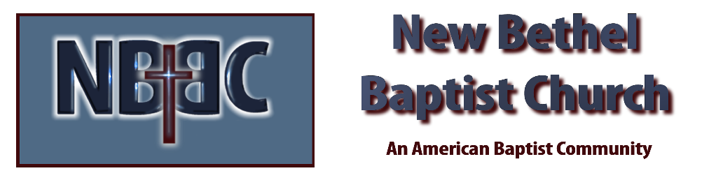

Sunday, April 23, 2023

Prelude Dr. Christina Romero

*Gathering Song Mighty to Save
Sanctuary

*Call to Worship Julianne Thomas
One: Come and enter into this Holy place.
Many: Where we can find comfort and rest with our God.
One: Come and begin this Holy time.
Many: When we meet with the Lord and find the comfort of the Spirit.
One: Come and worship the Lord.
Many: Come and find peace, comfort, and rest.

Invocation & Lord’s Prayer Julianne Thomas

*Hymn Leaning on the Everlasting Arms #575

Scripture Reading Daniel 8:15-27 Julianne Thomas
One: Hear what God is saying to the people.
All: Thanks be to God!

Worship Prayer Cares Chorus Rev. Tom Bartley

*Hymn Surely the Presence #219

Children and Youth Message Julianne Thomas

Scripture Reflection Ezekiel 37:24-28 Rev. Tom Bartley

*Hymn of Response A Mighty Fortress is our God #151

Offertory Dr. Christina Romero *Doxology
*Prayer Julianne Thomas

Benediction Rev. Tom Bartley

Postlude Dr. Christina Romero

CONTACT INFORMATION
New Bethel Baptist Church Website: www.newbethelbapt.org
8936 Southeastern Avenue E-mail: newbethelbapt@att.net Indianapolis, IN 46239 Wi-fi password: NBBC8624381
317-862-4381
Worship Music Copyright and Live-Streaming Permissions
All selections ©1997 Word/Integrity Used by Permission.
CCLI License #1631733

Live-Streaming: CCS, WorshipCast, License #10868

