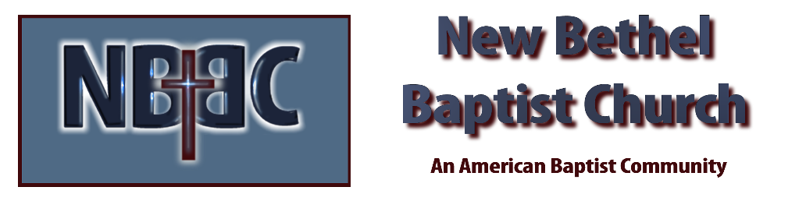
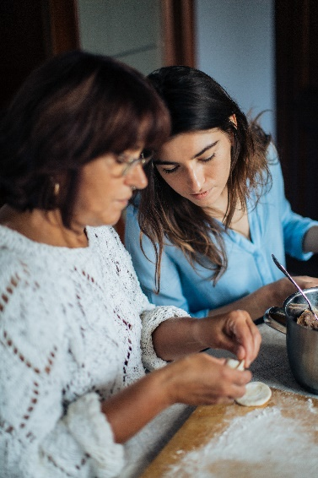
Sunday, April 30, 2023

Prelude Dr. Christina Romero

*Gathering Song Trading My Sorrows
Your Grace is Enough

*Call to Worship Julianne Thomas
Many: We are here. We have been called.
One: God has spoken and we have heard the call.
Many: We are called to life. We are called to be resurrection people.
One: Today we celebrate this new life. Now is the time to honor our God.
All: We worship you, O Lord. Hear the praise of your people.

*Invocation & Lord’s Prayer Julianne Thomas

Hymn To God be the Glory #56

Scripture Reading Daniel 9:1-19 Julianne Thomas
One: Hear what God is saying to the people.
All: Thanks be to God!

Worship Prayer Cares Chorus Rev. Tom Bartley

*Hymn Great is Thy Faithfulness #139

Children and Youth Message Julianne Thomas

Scripture Reflection Ruth 1:1-22 Rev. Tom Bartley

*Hymn of Response Nothing but the Blood #337

Offertory Dr. Christina Romero *Doxology
*Prayer Julianne Thomas

Benediction Rev. Tom Bartley

Postlude Dr. Christina Romero

CONTACT INFORMATION
New Bethel Baptist Church Website: www.newbethelbapt.org
8936 Southeastern Avenue E-mail: newbethelbapt@att.net Indianapolis, IN 46239 Wi-fi password: NBBC8624381
317-862-4381
Worship Music Copyright and Live-Streaming Permissions
All selections ©1997 Word/Integrity Used by Permission.
CCLI License #1631733

Live-Streaming: CCS, WorshipCast, License #10868

