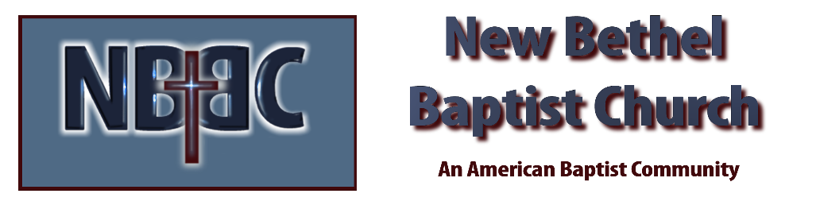

Easter Sunday, April 9, 2023

Prelude Dr. Christina Romero

*Gathering Song Jesus Messiah
Living Hope

Easter Proclamation & Lighting of Candles Julianne Thomas
One: Alleluia, Christ is risen!
All: Christ is risen indeed!

Invocation Julianne Thomas

*Hymn Christ Arose #357

Scripture Reading Daniel 7:15-28 Julianne Thomas
One: Hear what God is saying to the people.
All: Thanks be to God!

Worship Prayer Cares Chorus Rev. Tom Bartley

*Hymn Victory in Jesus #353

Children and Youth Message Julianne Thomas

Scripture Reflection Matthew 28:1-20 Rev. Tom Bartley

*Hymn of Response He Lives #368

Offertory Dr. Christina Romero *Doxology
*Prayer Julianne Thomas

Benediction Rev. Tom Bartley

Postlude Dr. Christina Romero

CONTACT INFORMATION
New Bethel Baptist Church Website: www.newbethelbapt.org
8936 Southeastern Avenue E-mail: newbethelbapt@att.net Indianapolis, IN 46239 Wi-fi password: NBBC8624381
317-862-4381
Worship Music Copyright and Live-Streaming Permissions
All selections ©1997 Word/Integrity Used by Permission.
CCLI License #1631733

Live-Streaming: CCS, WorshipCast, License #10868

