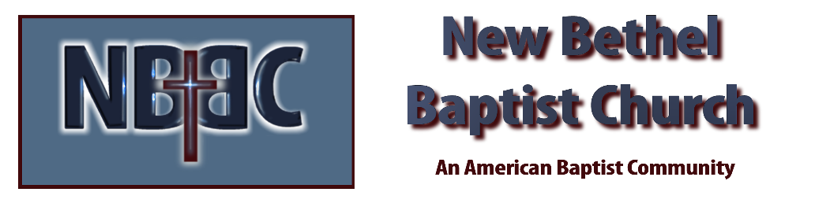

Maundy Thursday, April 6, 2023

Prelude Dr. Christina Romero

Welcome Rev. Tom Bartley

Invocation

Scripture Reading Matthew 26:14-30 Julianne Thomas

Communion Hymn Come Share the Lord #462

Communion Rev. Tom Bartley

Scripture Reading Matthew 26:31-35 Julianne Thomas

Commitment of Sins Rev. Tom Bartley

Scripture Reading Matthew 26:36-46 Julianne Thomas

Hymn In The Garden #635

Scripture Reading Matthew 26:47-56 Rev. Tom Bartley

Hymn I Need Thee Every Hour #638

Scripture Reading Matthew 26:57-68 Rev. Tom Bartley
Scripture Reading Matthew 26:69-75 Julianne Thomas

Hymn Hallelujah What a Savior #311
Scripture Reading Matthew 27:1-10 Rev. Tom Bartley

Last Words of Jesus Julianne Thomas

Scripture Reading Matthew27:11-26 Rev. Tom Bartley

Hymn Jesus Paid It All #305

Scripture Reading Matthew 27:27-31 Julianne Thomas

Scripture Reading Matthew 27:32-44 Rev. Tom Bartley

Hymn Beneath the Cross of Jesus #320

Scripture Reading Matthew 27:45-54 Rev. Tom Bartley

Lenten Meditation Julianne Thomas
Unison Prayer: What we contemplate this night is beyond words, beyond understanding. May the Holy Spirit intercede for us and give voice to what, for us, is inexpressible. Amen.

Extinguishing of the Lights Rev. Tom Bartley

*Please go forth in silence as you meditate on Jesus’ final words.

CONTACT INFORMATION
New Bethel Baptist Church Website: www.newbethelbapt.org
8936 Southeastern Avenue E-mail: newbethelbapt@att.net Indianapolis, IN 46239 Wi-fi password: NBBC8624381
317-862-4381
Worship Music Copyright and Live-Streaming Permissions
All selections ©1997 Word/Integrity Used by Permission.
CCLI License #1631733

Live-Streaming: CCS, WorshipCast, License #10868

