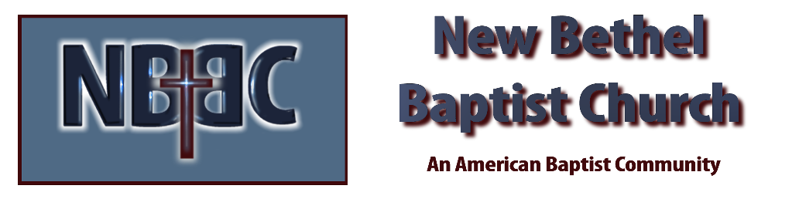

Sunday, May 14, 2023

Welcome

Greeting the Fellowship

Prelude Jaci Greig

*Gathering Song I Love You, Lord #78

*Call to Worship Julianne Thomas
One: God is love. We are created in God’s image to reflect and share that love.
Many: We celebrate human love as a gift. We are given families, friends and communities in which to receive and nurture love for one another.
One: On this Mother’s Day, we give thanks for our mothers who gave us the gift of life.
Many: We give thanks for all the women who have loved and shaped us, comforted and encouraged us, taught us and believed in us.
One: We ask your blessing upon these women, O Lord. May your love strengthen and support them each day.
Many: Grant them your grace and wisdom.
One: Anoint them with your presence and peace.
All: Thank you for your love and for family and friends with whom we share that love. Amen

*Invocation & Lord’s Prayer Julianne Thomas

Hymn Jesus Loves Me #185

Scripture Reading Daniel 11:1-13 Julianne Thomas
One: Hear what God is saying to the people.
All: Thanks be to God!

Worship Prayer Cares Chorus Julianne Thomas

*Hymn The Servant Song #424

Children and Youth Message Johnny Hopkins

Scripture Reflection John 15:9-17 Rev. Diane Cline
“Love”

*Hymn of Response Love Lifted Me #508

Offertory The King is Coming Jaci Greig & Wilma Waters *Doxology
*Prayer Julianne Thomas

Benediction Rev. Diane Cline

Postlude Jaci Greig

**Church members, please remain in the sanctuary after the postlude
for a brief business meeting.**

CONTACT INFORMATION
New Bethel Baptist Church Website: www.newbethelbapt.org
8936 Southeastern Avenue E-mail: newbethelbapt@att.net Indianapolis, IN 46239 Wi-fi password: NBBC8624381
317-862-4381
Worship Music Copyright and Live-Streaming Permissions
All selections ©1997 Word/Integrity Used by Permission.
CCLI License #1631733

Live-Streaming: CCS, WorshipCast, License #10868

