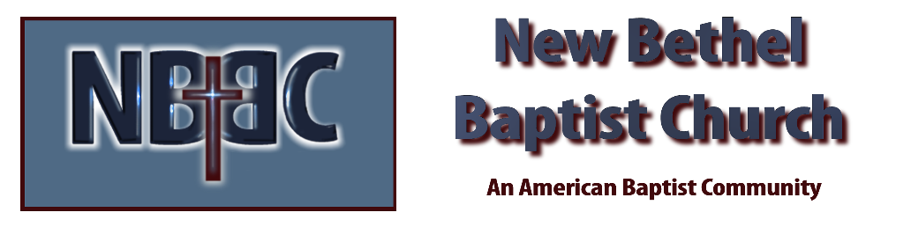

Pentecost Sunday, May 28, 2023

Welcome Rev. Tom Bartley

Greeting the Fellowship

Prelude Douglas Carter

*Gathering Song Light The Fire
Breathe

*Call to Worship Julianne Thomas
Many: Lord we are your church.
One: We are a community of people dedicated to your service.
Many: Lord we are your people.
One: We gather together to offer ourselves in service: to love one another, to love our neighbor.
Many: Lord we are renewed in You.
One: Today we celebrate the birth of the church and we are reminded of the new life and new choices God’s love makes available to us.
All: Amen.

*Invocation & Lord’s Prayer Julianne Thomas

Hymn Spirit of the Living God #389

Scripture Reading Genesis 11:1-9 Julianne Thomas
One: Hear what God is saying to the people.
All: Thanks be to God!

Worship Prayer Cares Chorus Rev. Tom Bartley

*Hymn Sweet Sweet Spirit #391

Children and Youth Message Julianne Thomas

Scripture Reflection Acts 2:1-13 Rev. Tom Bartley

*Hymn of Response Breathe on Me #396

Offertory Douglas Carter *Doxology
*Prayer Julianne Thomas

Benediction Rev. Tom Bartley

Postlude Douglas Carter

CONTACT INFORMATION
New Bethel Baptist Church Website: www.newbethelbapt.org
8936 Southeastern Avenue E-mail: newbethelbapt@att.net Indianapolis, IN 46239 Wi-fi password: NBBC8624381
317-862-4381
Worship Music Copyright and Live-Streaming Permissions
All selections ©1997 Word/Integrity Used by Permission.
CCLI License #1631733

Live-Streaming: CCS, WorshipCast, License #10868

