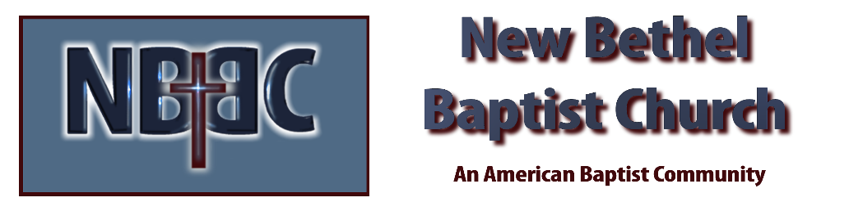

Sunday, June 11, 2023

Welcome Rev. Tom Bartley

Greeting the Fellowship

Prelude Jaci Greig

*Gathering Song You Are My King (Amazing Love)
Amazing Grace My Chains are Gone

*Call to Worship Julianne Thomas

*Invocation & Lord’s Prayer Julianne Thomas

Hymn The Old Rugged Cross #327

Scripture Reading Daniel 11:36-45 Julianne Thomas
One: Hear what God is saying to the people.
All: Thanks be to God!

Worship Prayer Cares Chorus Rev. Tom Bartley

*Hymn He Has Made Me Glad #214

Children and Youth Message Julianne Thomas

Scripture Reflection Ruth 4:1-22 Rev. Tom Bartley

*Hymn of Response Victory in Jesus #353

Invitation to Respond Julianne Thomas
One: It’s time to share…
Many: with those we know.
One: It’s time to share…
Many: with those we may never know.
One: It’s time to share
Many: when it seems easy…
One: And when it seems a more difficult task.
Many: It’s time to share!
One: Let us not grow weary.
All: For the time has come for us to share!
Offertory Jaci Greig *Doxology
*Prayer Julianne Thomas

Benediction Rev. Tom Bartley

Postlude Jaci Greig

CONTACT INFORMATION
New Bethel Baptist Church Website: www.newbethelbapt.org
8936 Southeastern Avenue E-mail: newbethelbapt@att.net Indianapolis, IN 46239 Wi-fi password: NBBC8624381
317-862-4381
Worship Music Copyright and Live-Streaming Permissions
All selections ©1997 Word/Integrity Used by Permission.
CCLI License #1631733

Live-Streaming: CCS, WorshipCast, License #10868

