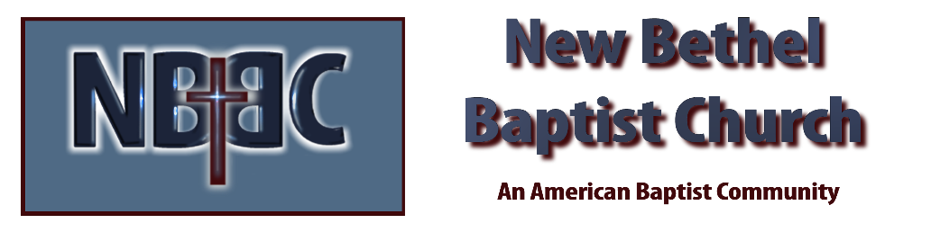

Sunday, June 18th, 2023

Welcome Rev. Tom Bartley

Greeting the Fellowship

Prelude Vivian Thomas

*Gathering Song Build Your Kingdom Here
Living Hope

*Call to Worship Source: Liturgies from Below: 462 Acts of Worship Julianne Thomas
One: Jesus said, “Come to me, all you are struggling hard and carrying heavy loads” (Matt 11:28).
Many: So we come, with all our weariness and wariness.
One: Our weariness with injustice, our weariness with fake news,
Many: Our weariness with a world that seems determined to be hostile rather than welcoming.
One: Our wariness of what it might mean to truly live out our call,
Many: Our wariness of how vulnerable our desire for openness might make us,
One: Our wariness of how safe it is to trust where trust has so often be misplaced.
All: Come, and find not just rest for your souls but channels for your rage.

*Invocation & Lord’s Prayer Julianne Thomas
Hymn He Keeps Me Singing #746

Scripture Reading Daniel 12:1-13 Julianne Thomas
One: Hear what God is saying to the people.
All: Thanks be to God!

Worship Prayer Cares Chorus Rev. Tom Bartley

*Hymn Count Your Blessings #786 v.1

Children and Youth Message Julianne Thomas

Mission Moment One Great Hour of Sharing

Scripture Reflection Welcoming a New Pastor 101 Rev. Tom Bartley
Mark 6:45-52

*Hymn of Response When We All Get to Heaven #772

Invitation to Respond Julianne Thomas

Offertory Vivian Thomas *Doxology
*Prayer Julianne Thomas

Benediction Rev. Tom Bartley

Postlude Vivian Thomas

*Please join us again for worship Saturday, June 24th at 6:00 p.m. This will be our weekly worship so we may connect with our community on Sunday.

CONTACT INFORMATION
New Bethel Baptist Church Website: www.newbethelbapt.org
8936 Southeastern Avenue E-mail: newbethelbapt@att.net Indianapolis, IN 46239 Wi-fi password: NBBC8624381
317-862-4381
Worship Music Copyright and Live-Streaming Permissions
All selections ©1997 Word/Integrity Used by Permission.
CCLI License #1631733

Live-Streaming: CCS, WorshipCast, License #10868

