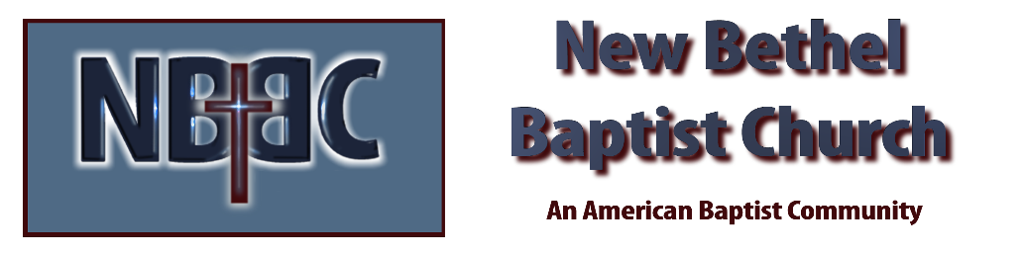
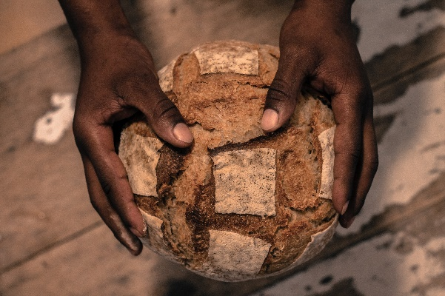
Saturday, June 24th, 2023

Welcome Rev. Tom Bartley

Greeting the Fellowship

Prelude Douglas Carter

*Gathering Song Jesus Messiah
How Great is Our God

*Call to Worship Julianne Thomas
One: Come, all you who are hungry. Come and dine with the Lord.
Many: We come to be nourished at the table of our God.
One: Come, you who are thirsty. Come and drink from the water of Life.
Many: We gather seeking the water that springs up to eternal life.
One: Come, all who are hungry for grace, thirsty for justice, come before the Lord and find the desire of your spirit.
All: We come to establish a bigger table, where more are welcome into the grace of God.

*Invocation & Lord’s Prayer Julianne Thomas
Hymn How Great Thou Art #147

Scripture Reading 1 Corinthians 11:17-26 Julianne Thomas
One: Hear what God is saying to the people.
All: Thanks be to God!

Worship Prayer Cares Chorus Rev. Tom Bartley

*Hymn Blessed Assurance #572

Children and Youth Message Rev. Tom Bartley

Scripture Reflection Mark 6:30-44 Rev. Tom Bartley

*Hymn of Response Come Share the Lord #462

Communion

Invitation to Respond Julianne Thomas

Offertory Douglas Carter *Doxology
*Prayer Julianne Thomas

Benediction Rev. Tom Bartley

Postlude Douglas Carter

CONTACT INFORMATION
New Bethel Baptist Church Website: www.newbethelbapt.org
8936 Southeastern Avenue E-mail: newbethelbapt@att.net Indianapolis, IN 46239 Wi-fi password: NBBC8624381
317-862-4381
Worship Music Copyright and Live-Streaming Permissions
All selections ©1997 Word/Integrity Used by Permission.
CCLI License #1631733

Live-Streaming: CCS, WorshipCast, License #10868

