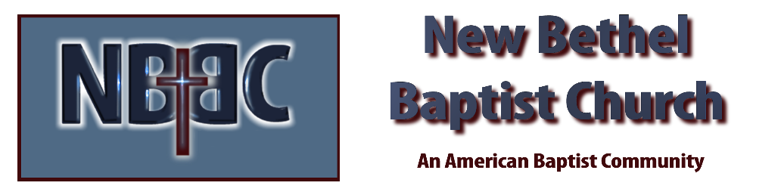
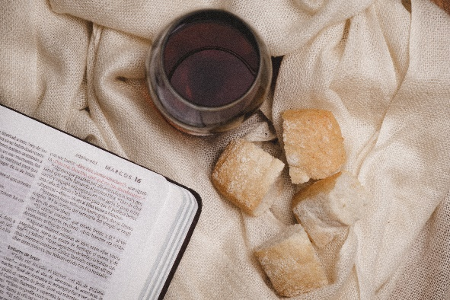
Communion Sunday, June 4, 2023

Welcome Rev. Tom Bartley

Greeting the Fellowship

Prelude Jaci Greig

*Gathering Song Here I Am to Worship
The Heart of Worship

*Call to Worship Julianne Thomas
One: Come, all you who desire a connection to our Lord.
Many: We gather to connect with our Lord, with one another, and to find peace in our own self.
One: Come, you who hunger and thirst for righteousness. Come and be blessed by our Lord.
Many: For God abounds with love and mercy for those who are suffering.
One: Come, you who have reason to shout for joy. Come and bring praise to our God.
Many: We come to share our joy, to thank our God, and to witness to God’s deliverance.
One: Come and worship. Come and worship
All: Worship Christ, the Risen King.

*Invocation & Lord’s Prayer Julianne Thomas

Hymn Come, Christians Join to Sing #225

Scripture Reading Daniel 11:29-35 Julianne Thomas
One: Hear what God is saying to the people.
All: Thanks be to God!

Worship Prayer Cares Chorus Rev. Tom Bartley

*Hymn Great is the Lord #140

Children and Youth Message Julianne Thomas

Scripture Reflection Ruth 3:1-18 Rev. Tom Bartley

*Hymn of Response The Church’s One Foundation #401

Offertory Jaci Greig *Doxology
*Prayer Julianne Thomas

Communion Hymn Come Share the Lord #462

Communion

Benediction Blest Be the Ties That Bind Rev. Tom Bartley

Postlude Jaci Greig

CONTACT INFORMATION
New Bethel Baptist Church Website: www.newbethelbapt.org
8936 Southeastern Avenue E-mail: newbethelbapt@att.net Indianapolis, IN 46239 Wi-fi password: NBBC8624381
317-862-4381
Worship Music Copyright and Live-Streaming Permissions
All selections ©1997 Word/Integrity Used by Permission.
CCLI License #1631733

Live-Streaming: CCS, WorshipCast, License #10868

