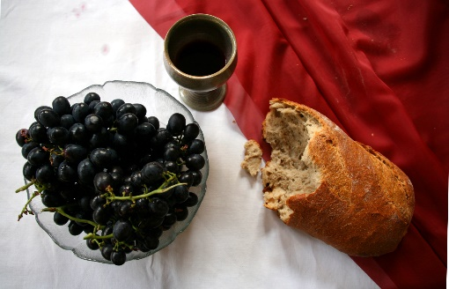

*Communion Sunday, July 2nd, 2023*

**Welcome** Pastor Dianna Cline

**Greeting the Fellowship**

**Prelude**  Jaci Greig

**\*Gathering Song** *Holy Ground #217*

**\*Call to Worship**  Julianne Thomas

*One: Come, all you seeking forgiveness and grace. Come and be renewed by God’s unconditional love.*

**Many: We come before God with repentant hearts.**

*One: Come, all who are lost in guilt and shame. Come and find freedom in God’s redeeming love.*

**Many: We come seeking the path of Light, to bring us out of the darkness.**

*One: Come, all who seek a life of everlasting peace.*

**All: We come seeking God’s love. We come seeking God’s light. We come seeking God’s peace.**

**\*Invocation & Lord’s Prayer**  Julianne Thomas

**Hymn**  *Just As I Am #488*

**Scripture Reading** *Psalm 1* Julianne Thomas

*One: Hear what God is saying to the people.*

**All: Thanks be to God!**

**Worship Prayer** *Cares Chorus* Pastor Dianna Cline

**\*Hymn** *Cleanse Me #657*

**Children and Youth Message** Julianne Thomas

**Scripture Reflection**  ***Prison or Freedom*** Pastor Dianna Cline

*Romans 6:12-23*

**\*Hymn of Response** *I Need Thee Every Hour #638*

**Invitation to Respond** Julianne Thomas

**Offertory**  Jaci Greig **\*Doxology**

**\*Prayer** Julianne Thomas

**Communion Hymn** *In Remembrance* *#461*

**Communion**

**Benediction**  *Blest Be The Ties That Bind*Pastor Dianna Cline

**Postlude**  Jaci Greig

**CONTACT INFORMATION**

New Bethel Baptist Church **Website:** www.newbethelbapt.org

8936 Southeastern Avenue **E-mail:** newbethelbapt@att.net Indianapolis, IN 46239 **Wi-fi password:** NBBC8624381

317-862-4381

**Worship Music Copyright and Live-Streaming Permissions**

All selections ©1997 Word/Integrity Used by Permission.

CCLI License #1631733

Live-Streaming: CCS, WorshipCast, License #10868